Using GitHub Desktop
for the
Ethos manual

Table of Contents
Overview 4
Preparation 4
How to clone ethos-manual to your local machine. 4
Keeping your local copy up to date 6
Checking the changes between EN revisions 9
Uploading your completed manual 13
Releasing your completed manual 17
Dealing with an unexpected merge request 21
Removing your local repo and starting again 22

Overview
This document describes how to set up Github Desktop for use with the ethos-manual repository on GitHub.

Preparation

1. Install GitHub Desktop on your PC

2. Install Libreoffice on your PC. This is used to edit the manual source file.

How to clone ethos-manual to your local machine.

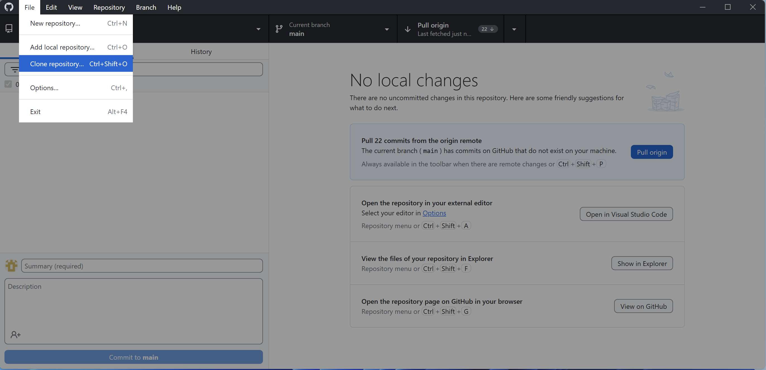

1. Open Github Desktop.
2. Go to File / Clone repository (see above).
3. Hit ‘Enter’.

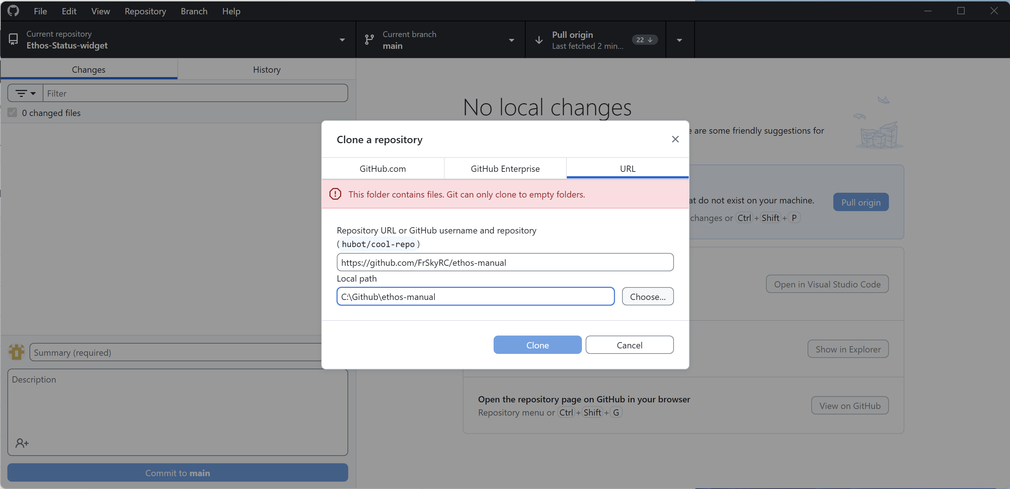

3. Select the right hand URL tab.
4. Fill in the URL for ethos-manual - https://github.com/FrSkyRC/ethos-manual
5. Accept the default Local path. (Ignore the warning in pink, I got that because I already have my local repo at ‘C:\Github\ethos-manual. You won’t get this warning message).
6. Hit ‘Clone’.

You should now have a clone of ethos-manual on your local machine.

Keeping your local copy up to date

We use a ‘Repository Pull’ to update the local copy.

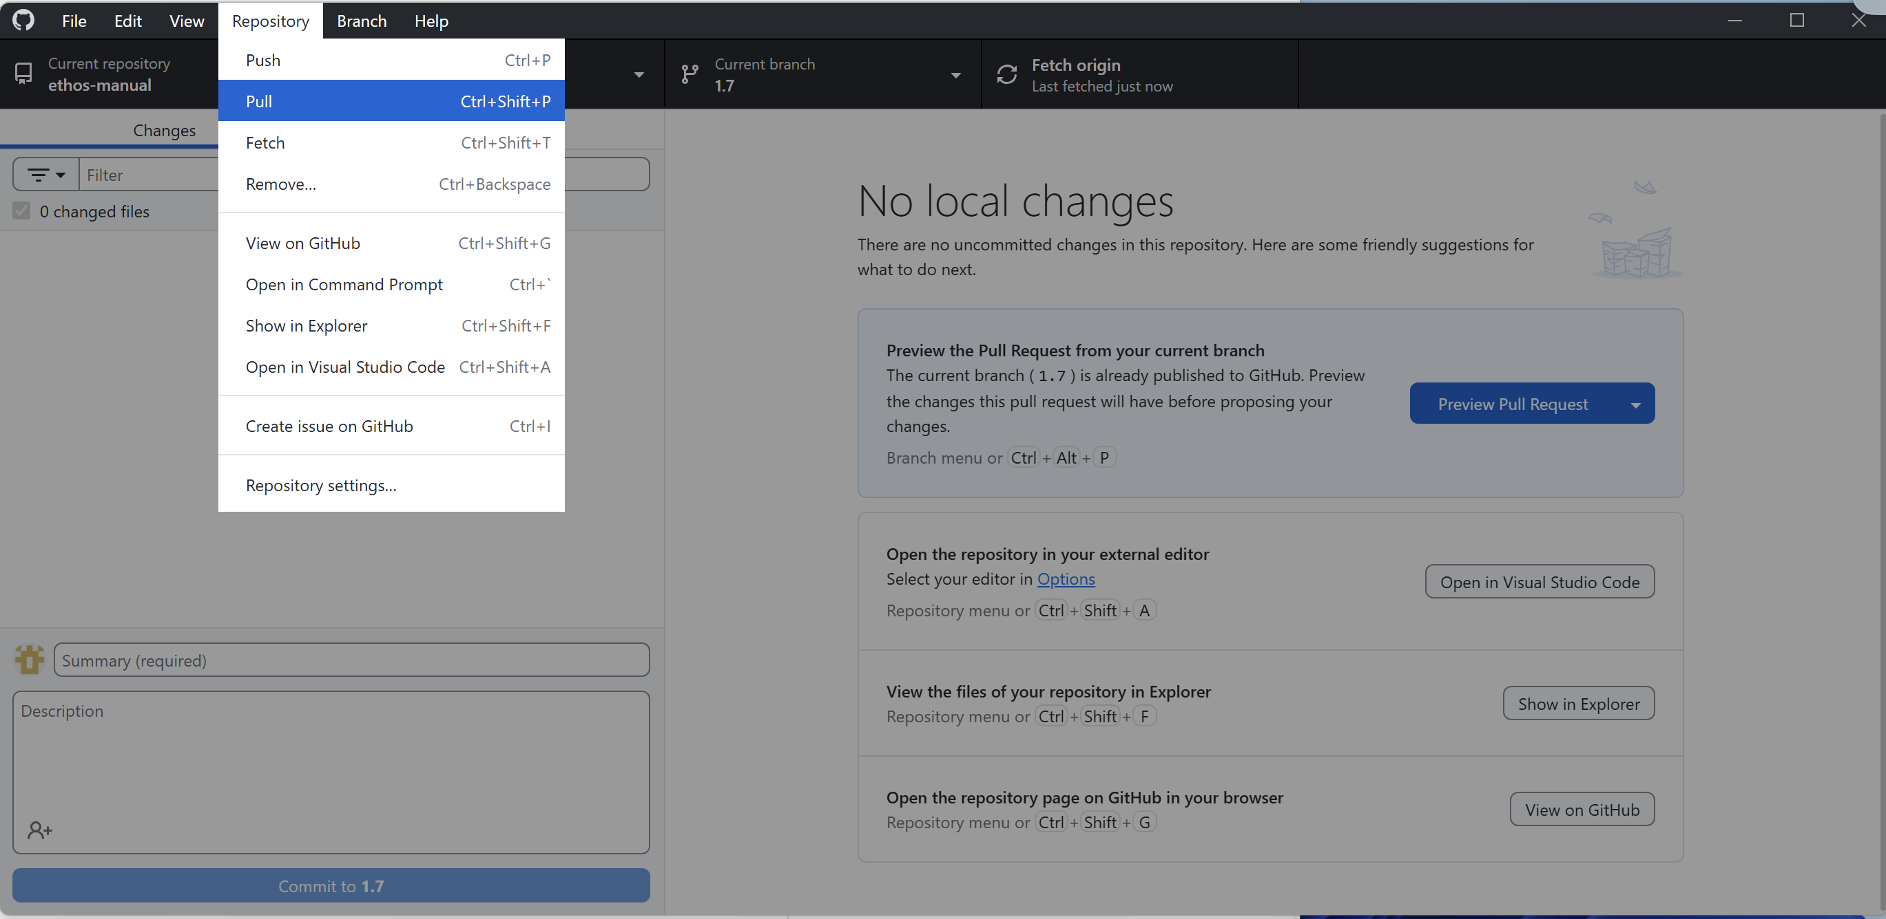

1. Check that your current repo is set to ‘ethos-manual’ (see top left of screen).
2. Set the current branch to ‘1.7’ (see top middle of acreen).
3. Go to Repository, then click on Pull. This will synch your local copy to the master.

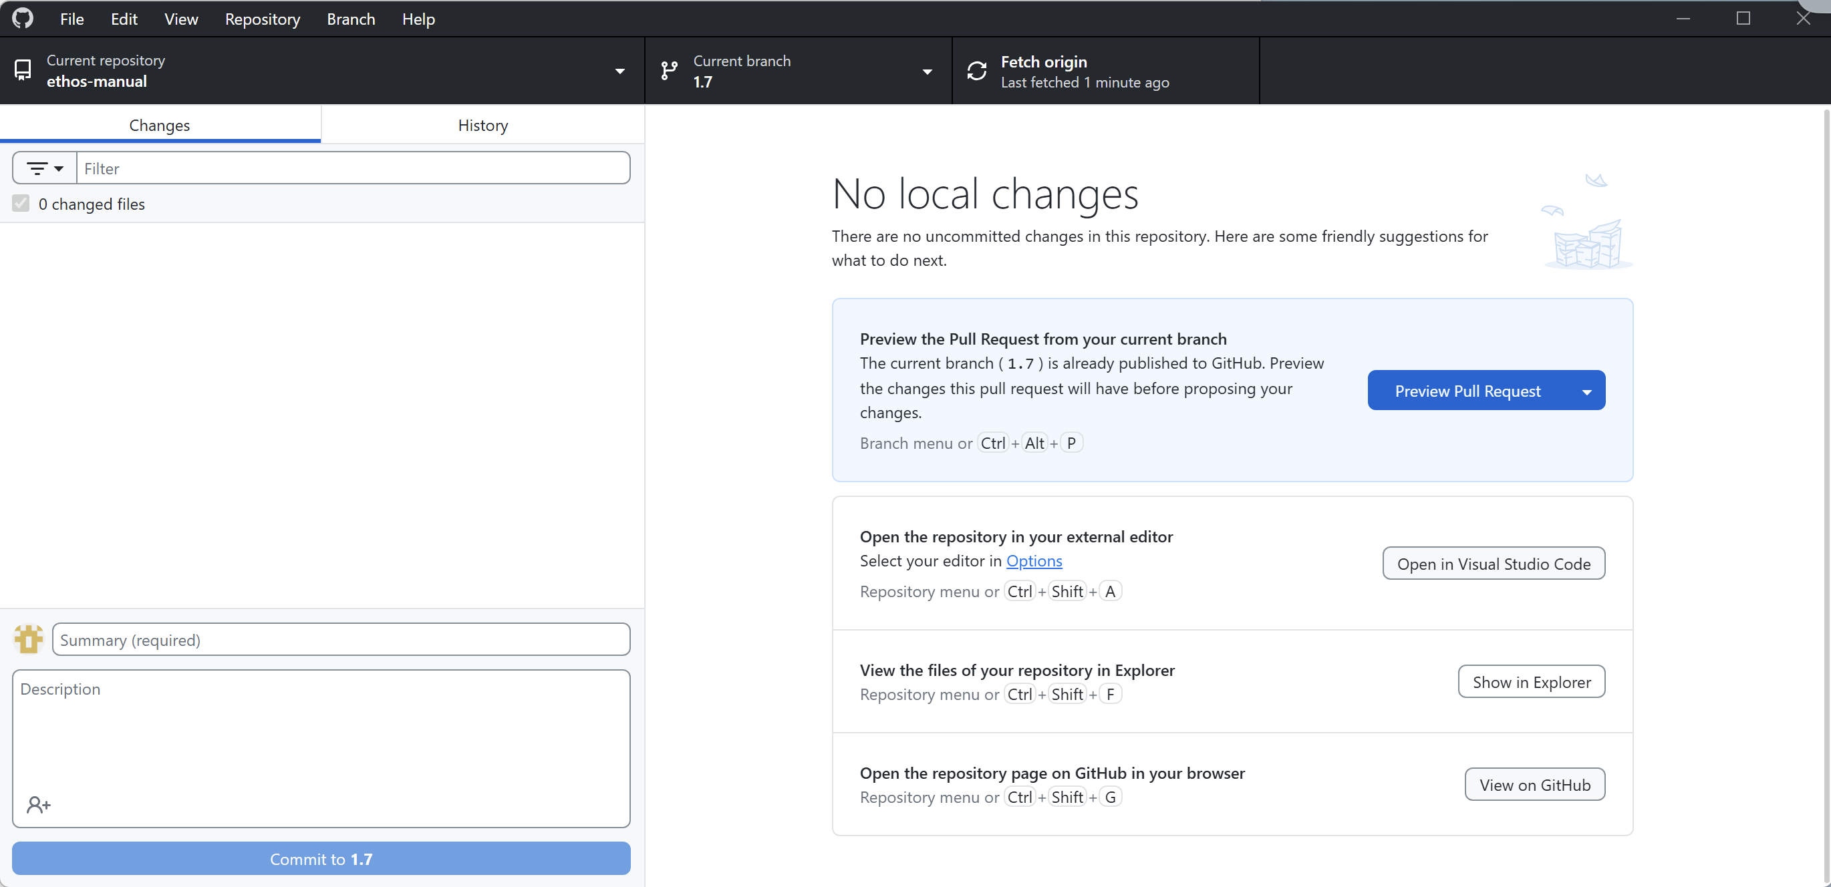

4. Check that the fetch is new (top right should say something like ‘Last fetched 1 minute ago.)
5. Click on the ‘Show in Explorer’ button (see near bottom right).

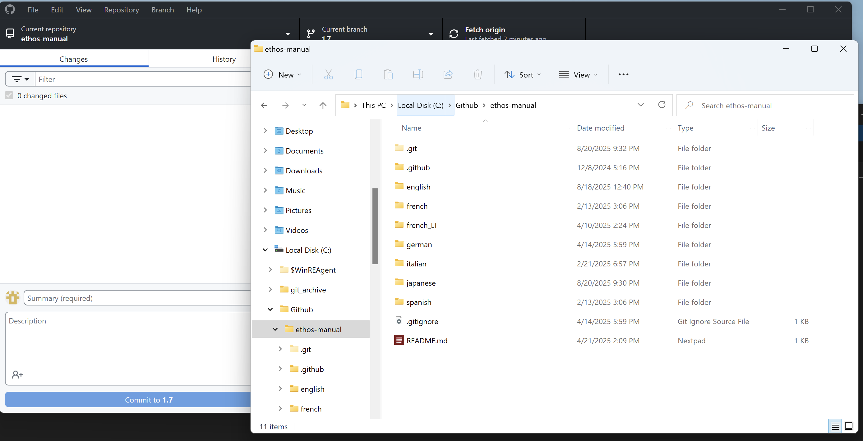

5. A File Explorer window should open (see above). Each language has its own folder.

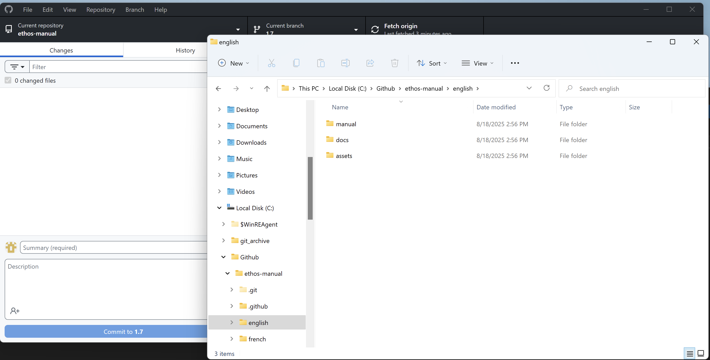

6. Navigate to ethos-manual/english/docs
7. Copy the latest .odt file (e.g. [EN] Ethos User Manual 1.7.0rev0.odt) to your working folder outside of the GitHub clone. Note: never work in the GitHub folders, because GitHub will flag differences and lead you to push your files to the repo. This must never be done! Never push or merge to the ethos-manual repository. Consider it to be read only!
8. Also copy the latest .pdf version for use as a reference to the EN manual.
9. Note that the ‘Ethos_changes.ods‘ file lists the changes made in the manual from version to version. The ‘changelog’ tab keeps track of the Ethos release notes and github issues. The ‘doc_updates’ tab lists the changes to the manual. The ‘image_links’ tab lists the hyperlinks that control the screenshots.
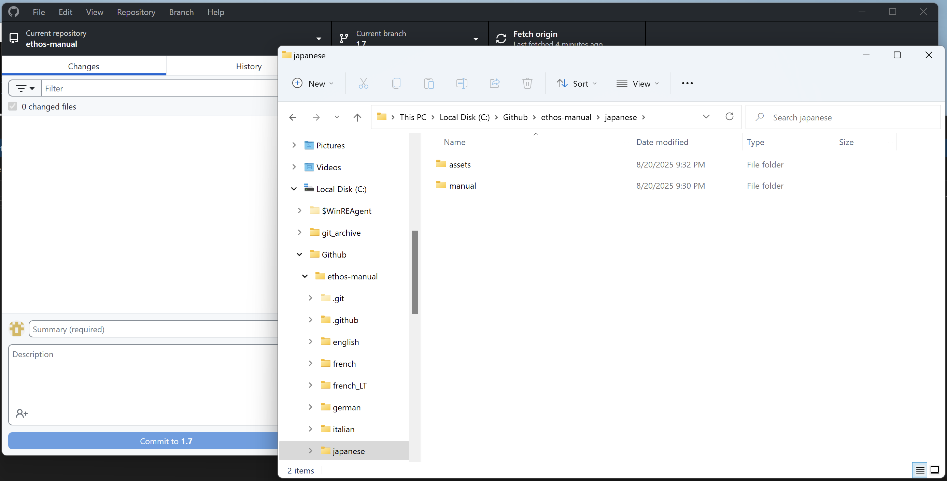

10. Create an /assets folder beneath your manual’s working folder. Copy all the screenshot image files from ethos-manual/<your_language>/assets to your working assets folder.
11. Now open the copied .odt file. You will notice that the images will be in your language, because the file contains hyperlinks to the screenshots in the /assets sub folder. (Note that for all this to be automated the screenshot filenames remain the English ones, but the actual content is different for each language.)
12. Save the file in the format ‘[XX] Ethos User Manual 1.7.0revn.odt’ where XX=DE or ES or FR or IT or JP or the two letter acronym for your language.
13. Now you can start translating!

Checking the changes between EN revisions
1. Follow steps 1 to 9 of the ‘Keeping your local copy up to date’ section above.
2. You should now have the latest EN revision in your local working folder, as well as the previous revision.

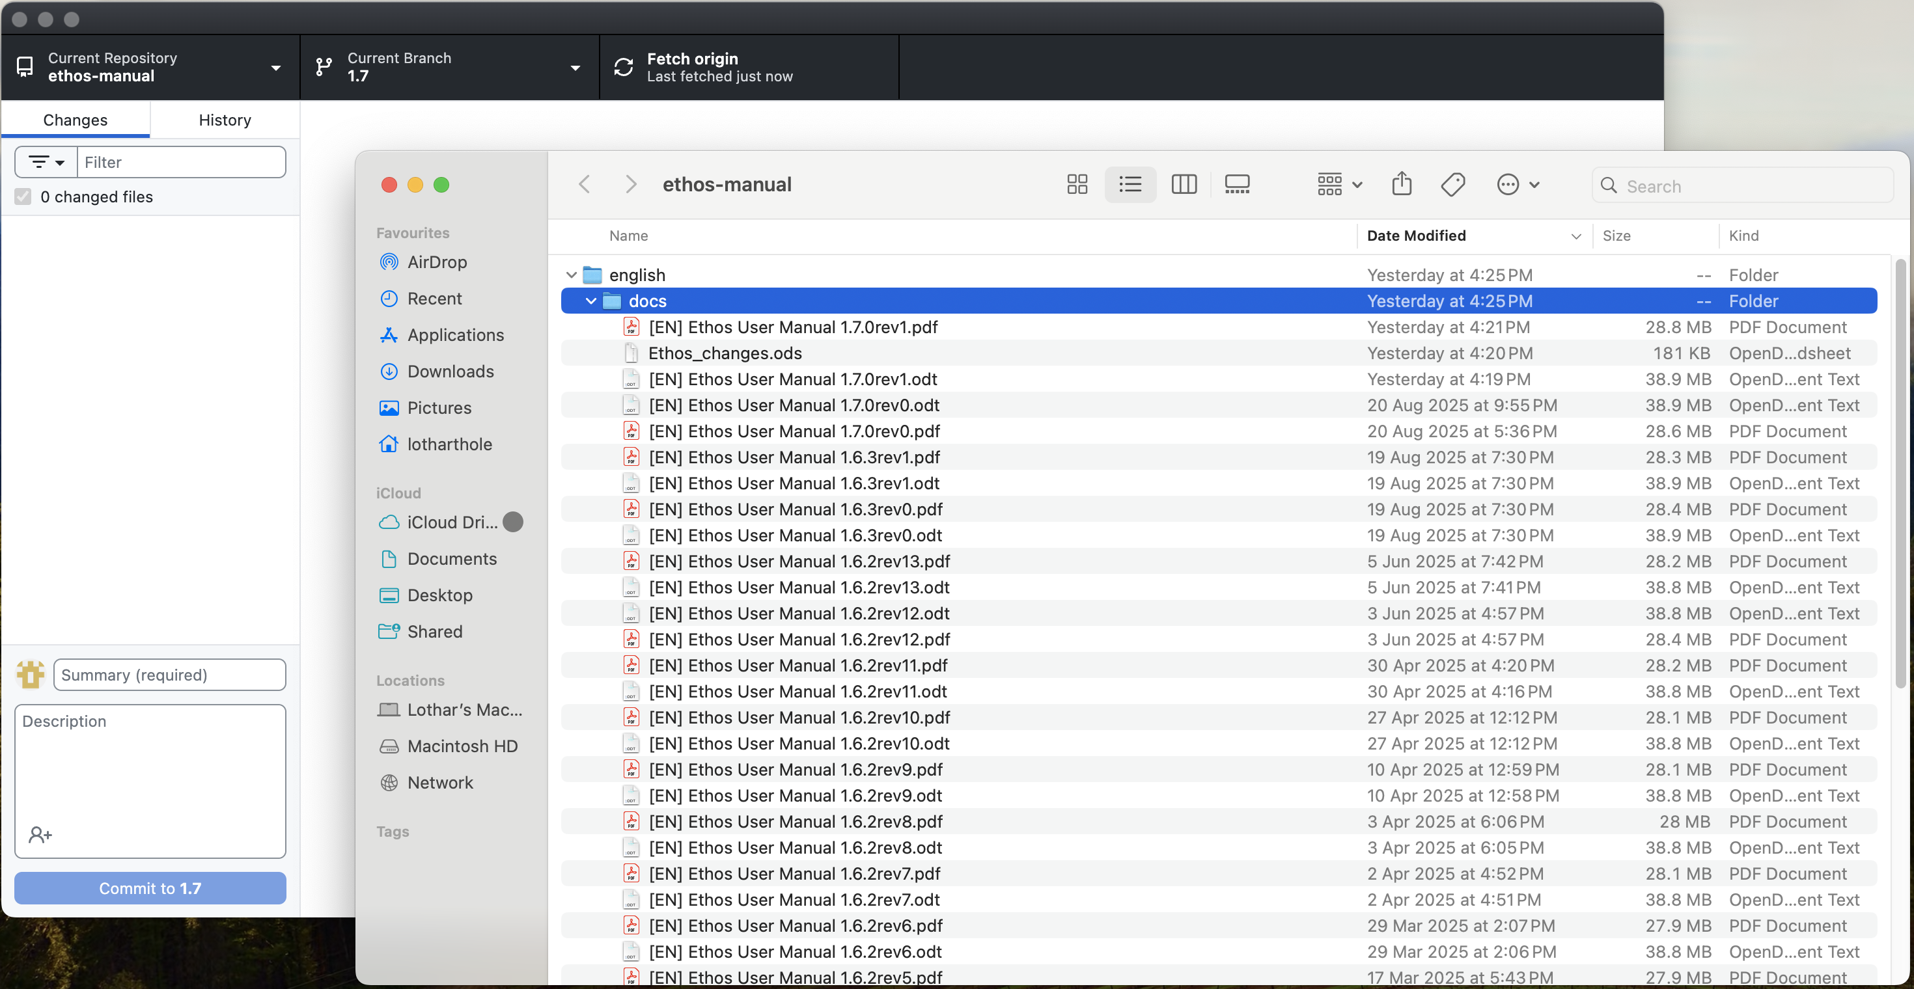

3. For this exercise we will assume that ‘[EN] Ethos User Manual 1.7.0rev1.odt’ is the new revision. See above.

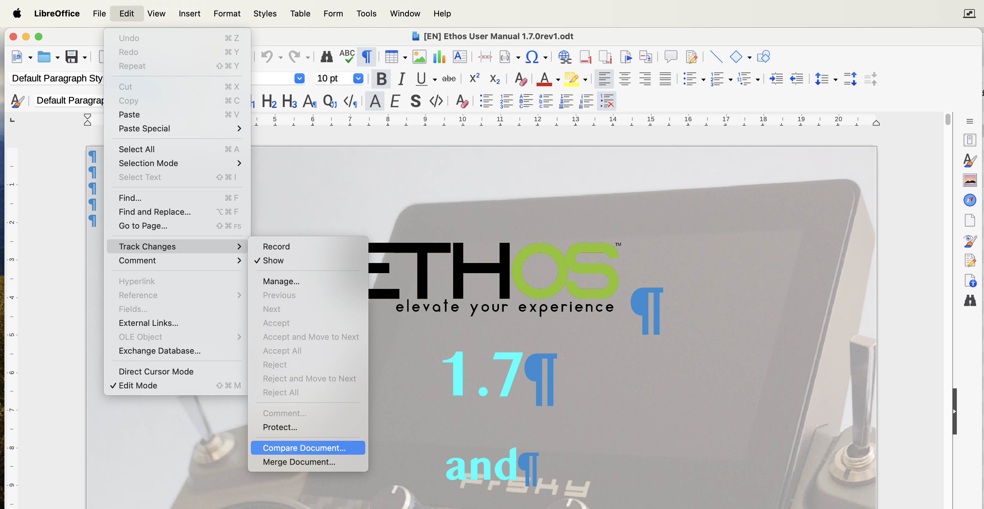

4. Open the latest revision in LibreOffice, i.e. ‘[EN] Ethos User Manual 1.7.0rev1.odt’. See above.
5, Then navigate to Edit / Track Changes / Compare Document and select it.

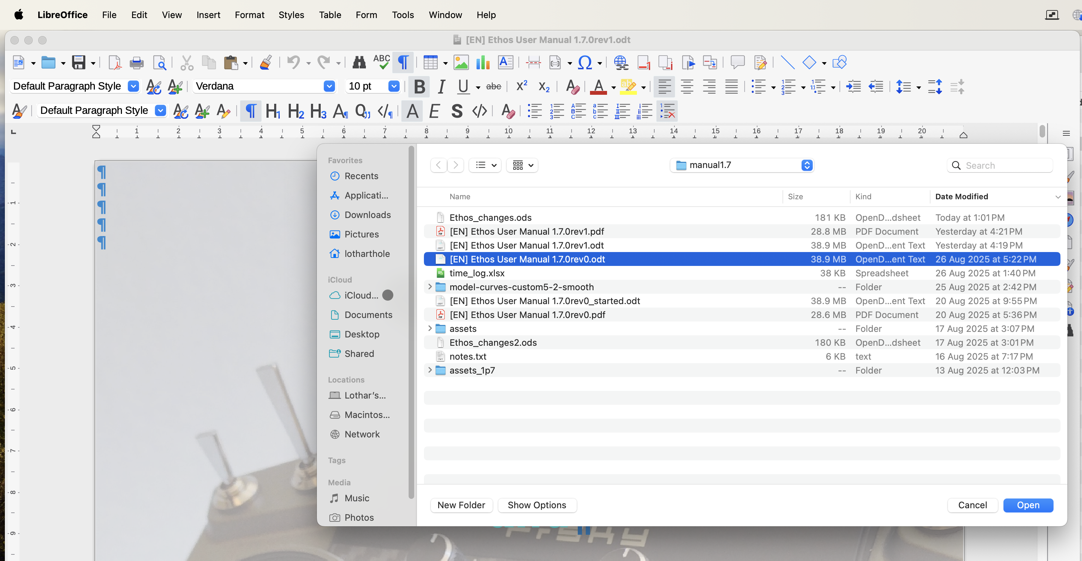

6. Navigate to your working folder and select the previous EN revision. See above.

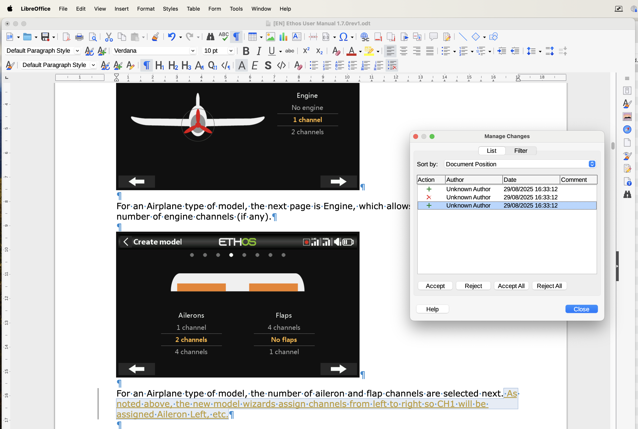

7. A dialog ‘Manage Changes’ opens with a list of changes between rev0 and rev1. One of the changes is shown above.
8. Work your way through the list of changes in the dialog.
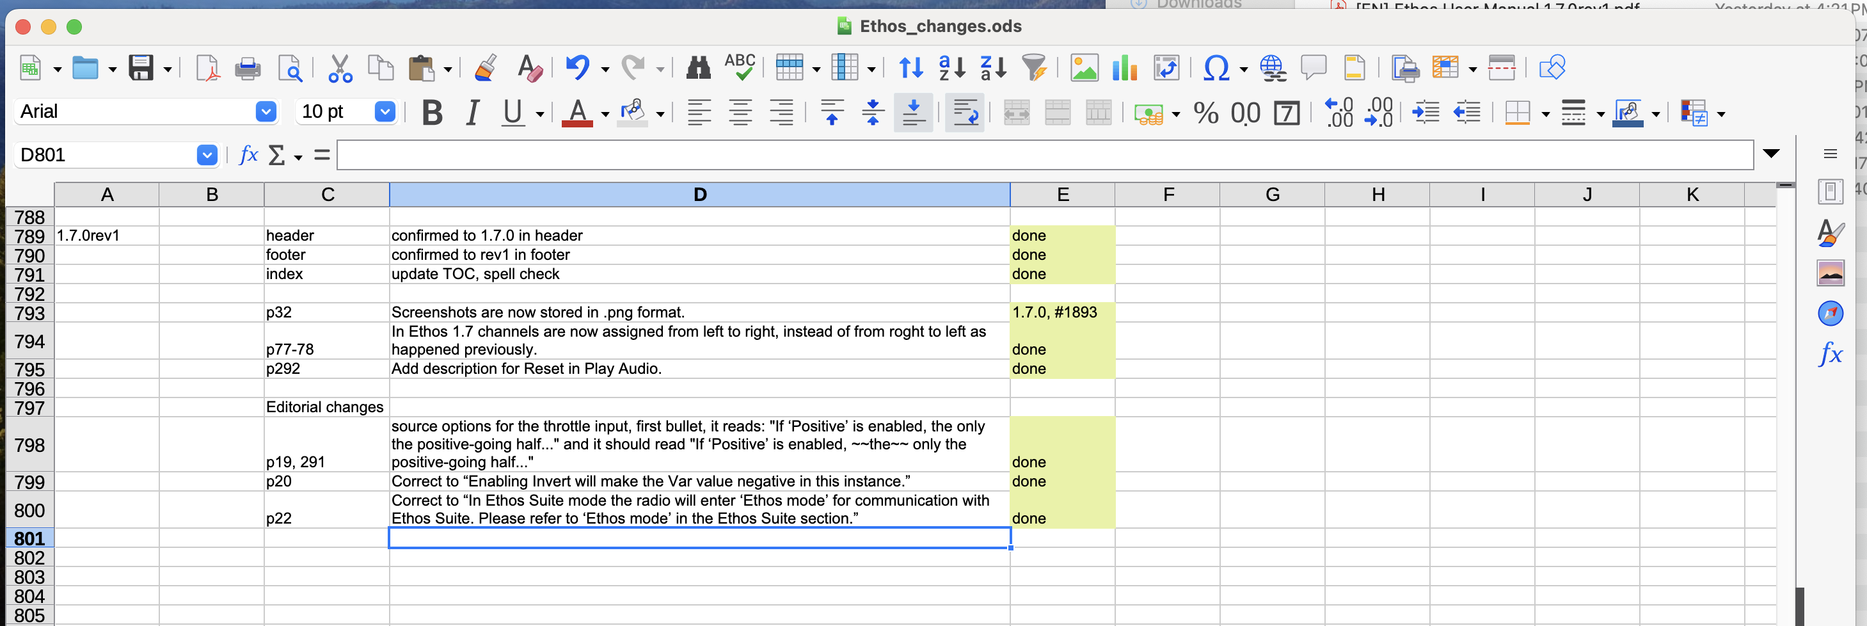

9. Between the ‘Manage Changes’ above, and the list of changes in the ‘doc updates’ tab of ‘Ethos_changes.odt’ you can identify all the differences in the new revision.

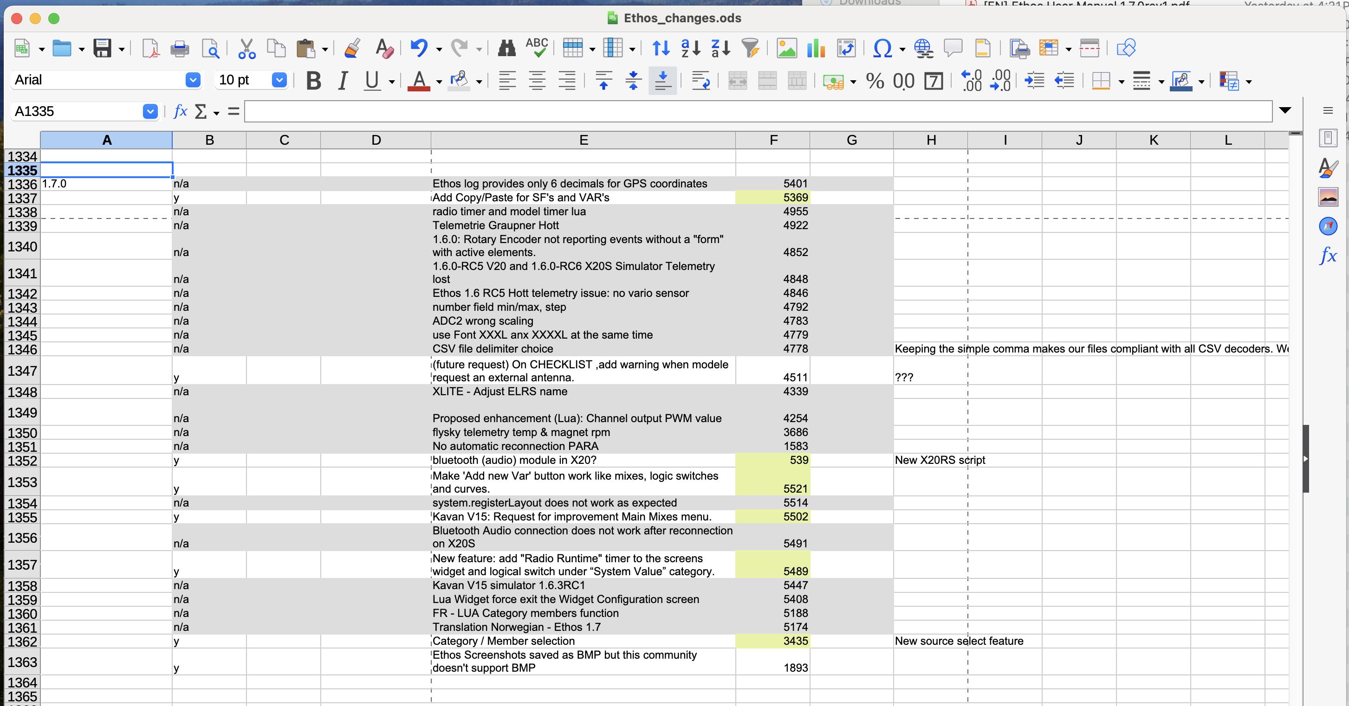

10. You can also refer to the ‘changelog’ tab for references to the GitHub issues for the changes.

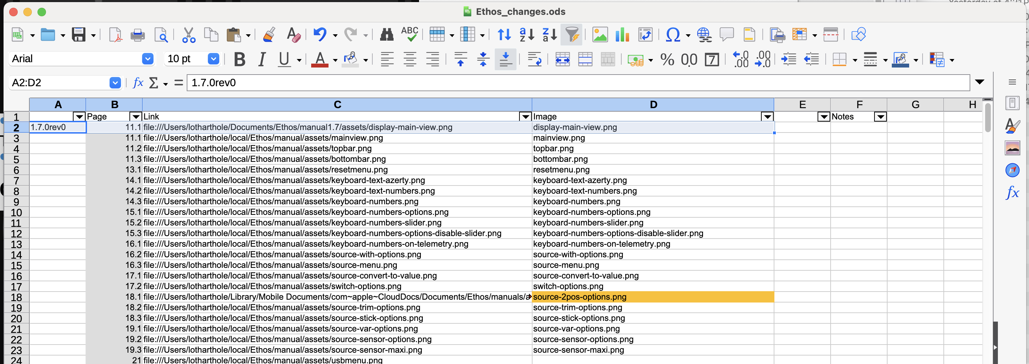

11. The ‘image_links’ tab has details of the screenshot hyperlinks in the document. See the example on page 11 above.
12. The combined change lists should provide sufficient information to locate the updates to the manual that need translation.

Uploading your completed manual
In this section you will be updating files in the remote ethos-manual repository. It is vital that you follow the correct process to avoid getting into difficulties.

Before beginning the upload your files should be ready for uploading.

Overview
The correct sequence of steps is as follows:
A. Repository Pull, immediately followed by pasting your updated .odt and .pdf files into the local clone to the ethos-manual/<your_language>/docs folder.
B. Confirm in the Changes tab that only your two files are listed as changed.
C. Commit the changes
D. Push the changes
E. Confirm there are no changes remaining.

Procedure
1. Before uploading the manual, you must refresh your local Github repository. Please follow steps 1 to 5 as described above in ‘Keeping your local copy up to date’.

This will do a ‘Repository Pull’ to update the local copy, and then you will open Windows explorer.

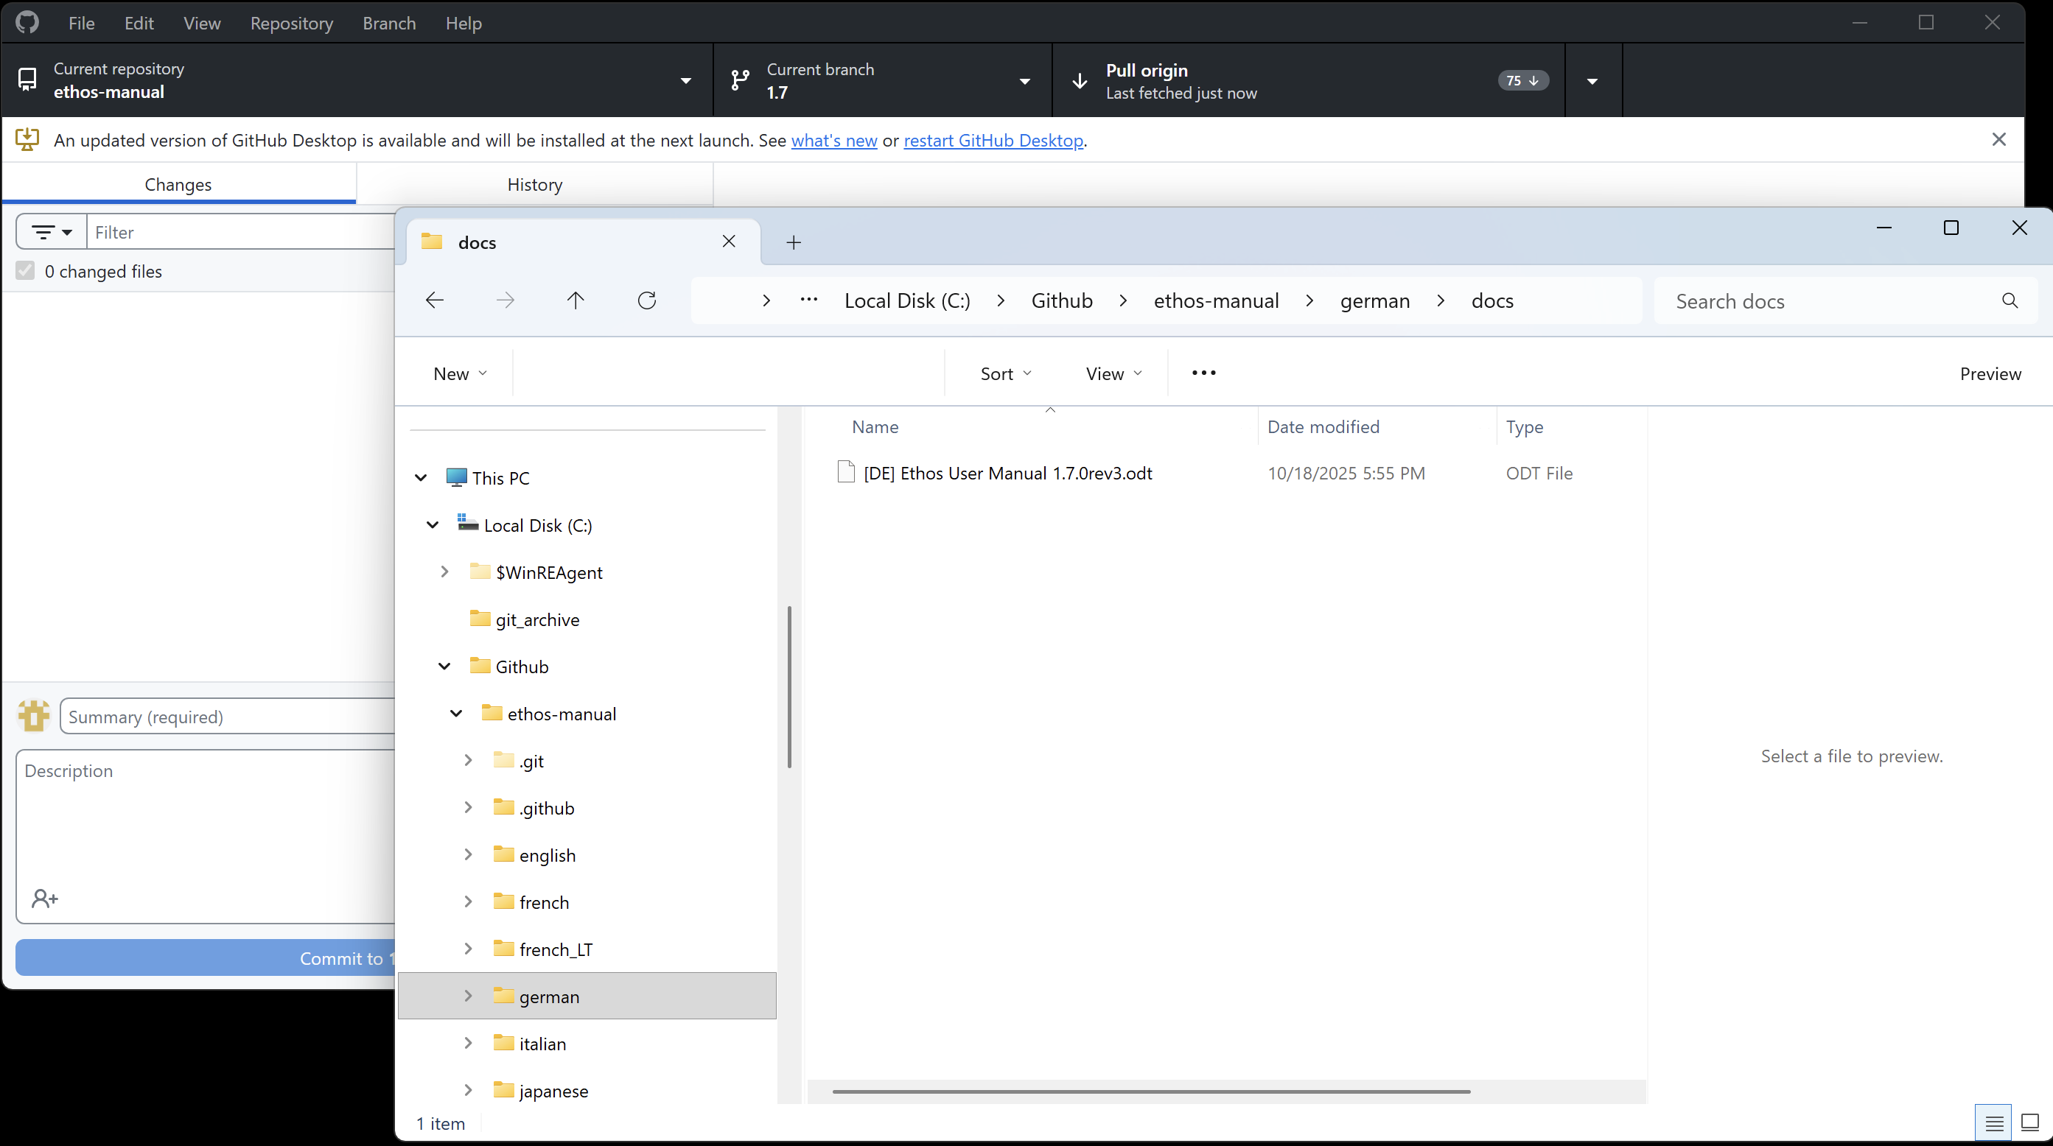

2. In Windows Explorer navigate to your docs folder, for example ethos-manual/german/docs.

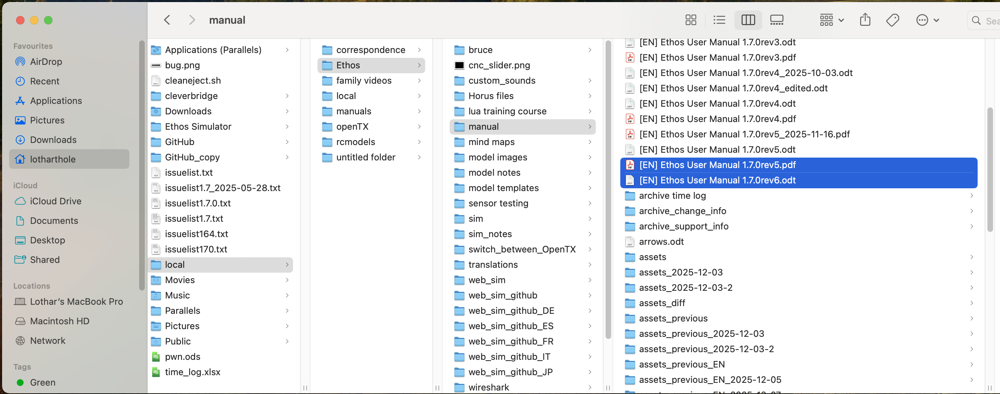

3. Go to your local folder where you have prepared the manual, and copy the files needed.

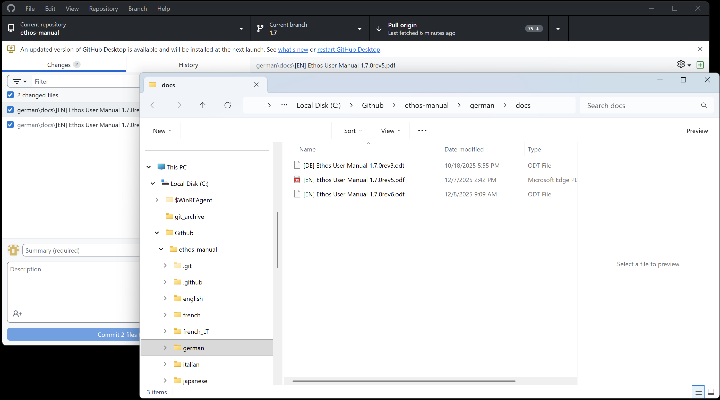

4a. At this point do another Pull just in case someone has just done an update to the remote repository while you were preparing your files.

4b. Paste the files into your local github repository in the ethos-manual/<your_language>/docs folder. (Please ignore the fact that two EN files have been pasted in the example, just paste the correct ones.)

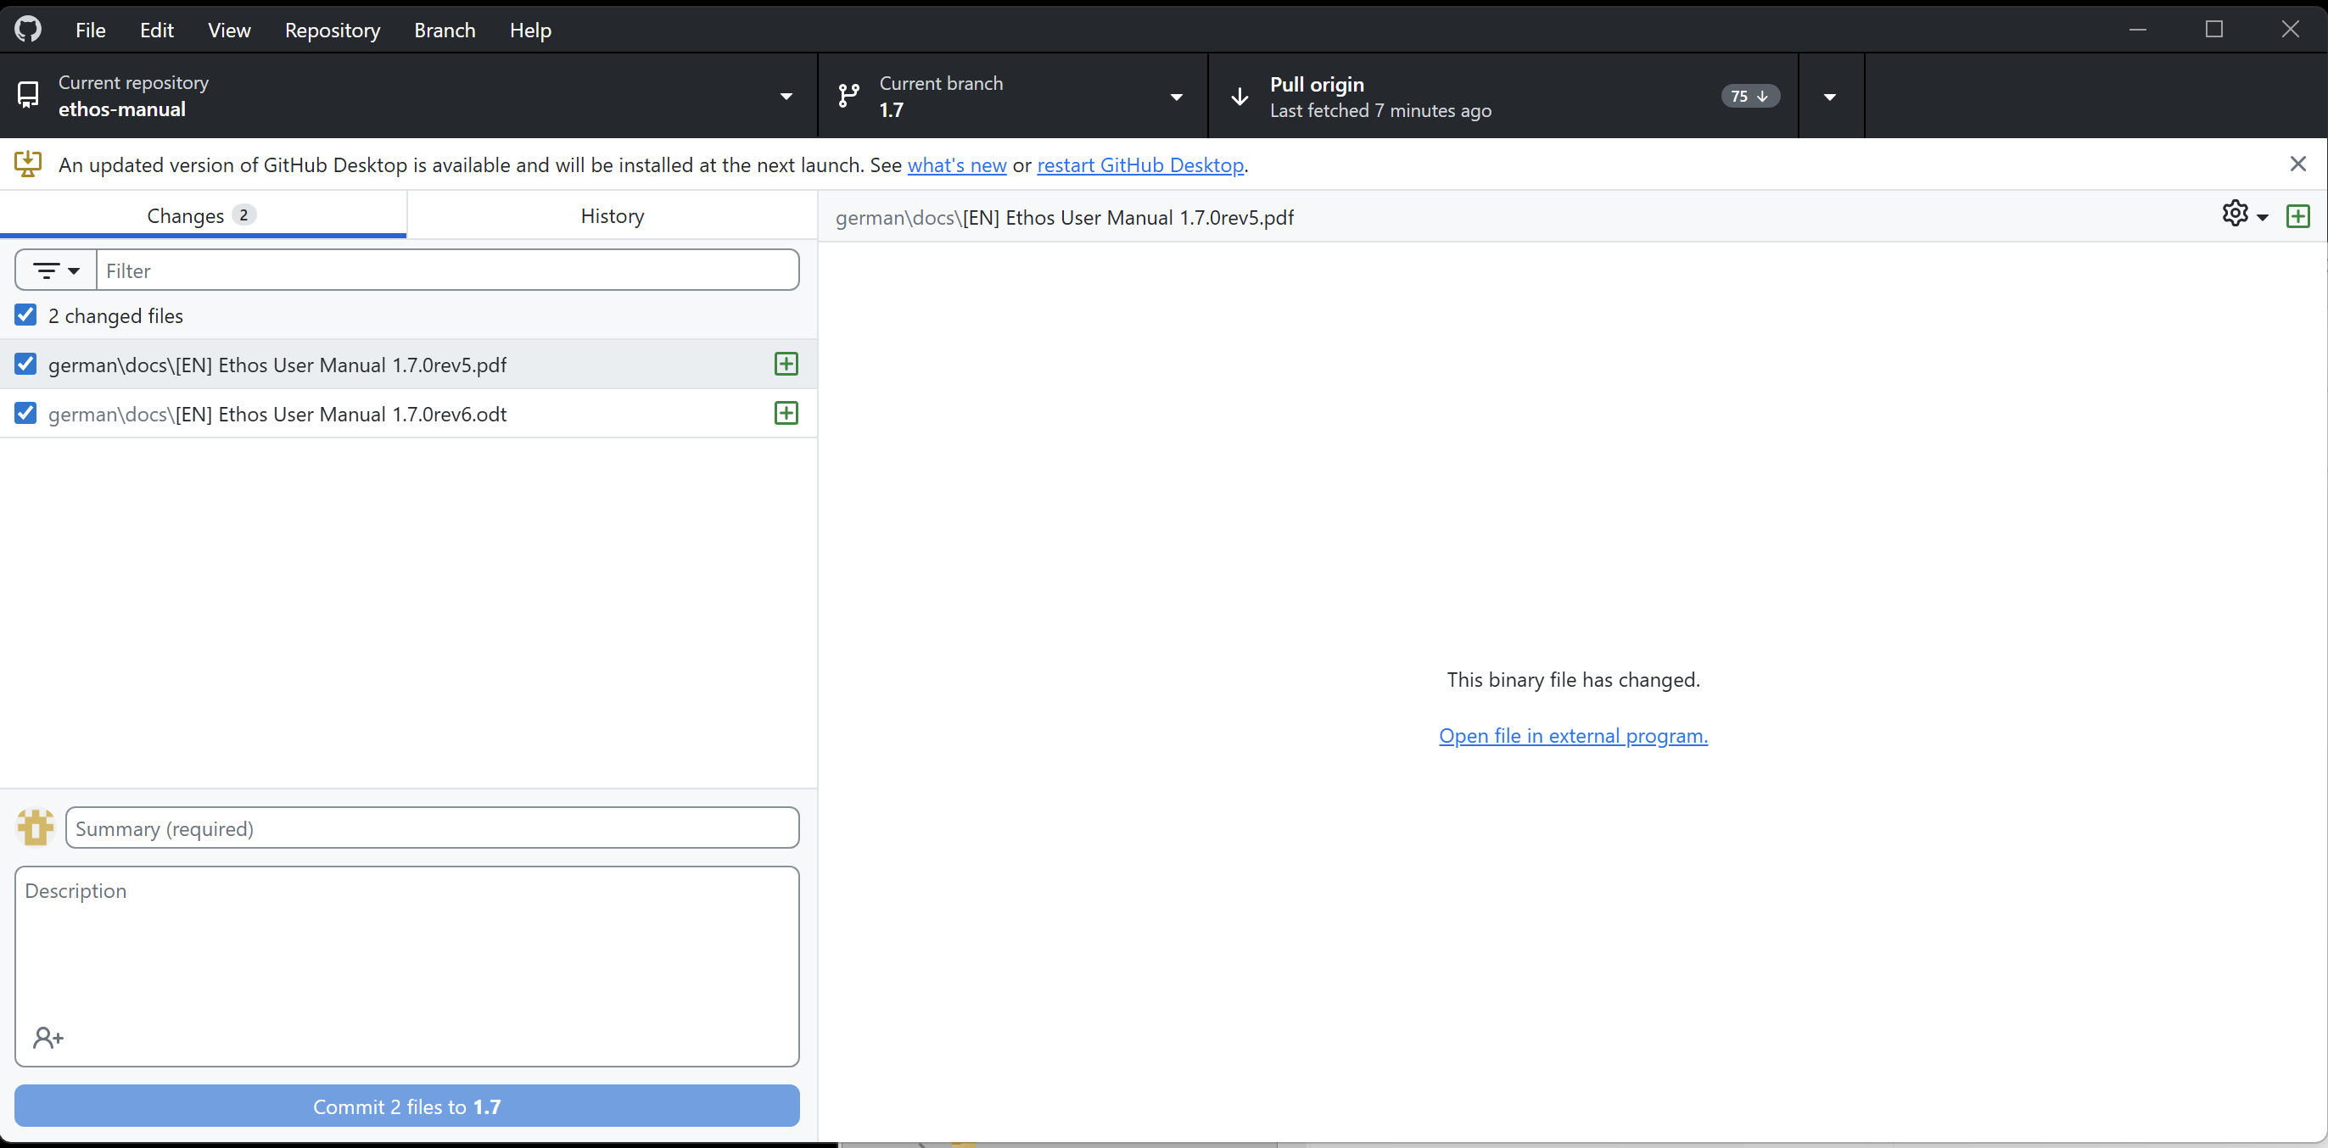

5. Go back to GitHub Desktop, and confirm that ONLY the two files you pasted are shown under the ‘Changes’ tab.

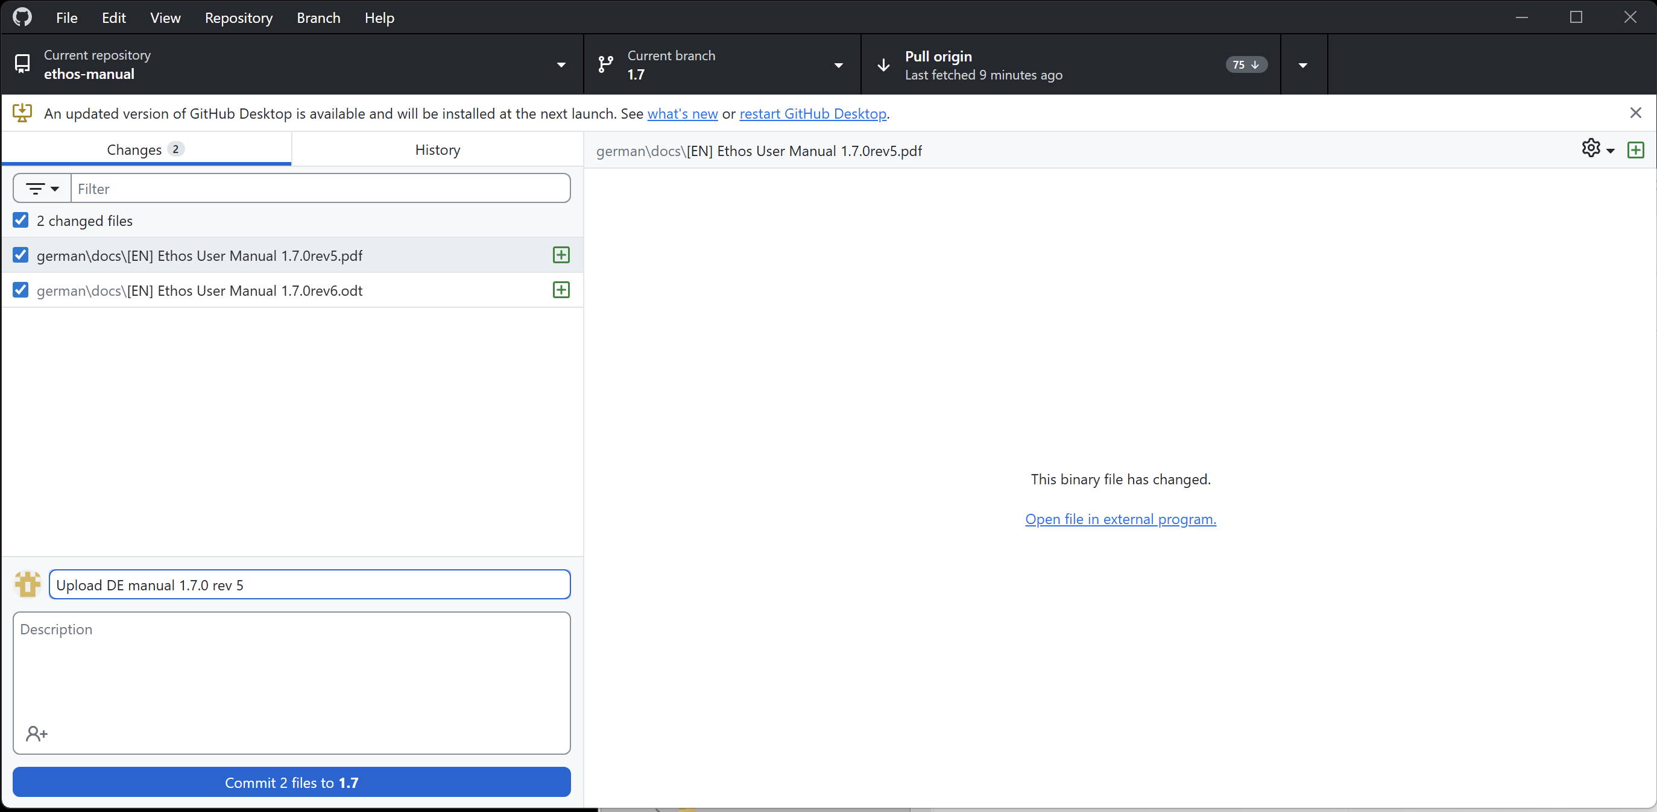

6. Fill in a suitable Commit summary in the Commit comment box, then click on ‘Commit 2 files to 1.7’.

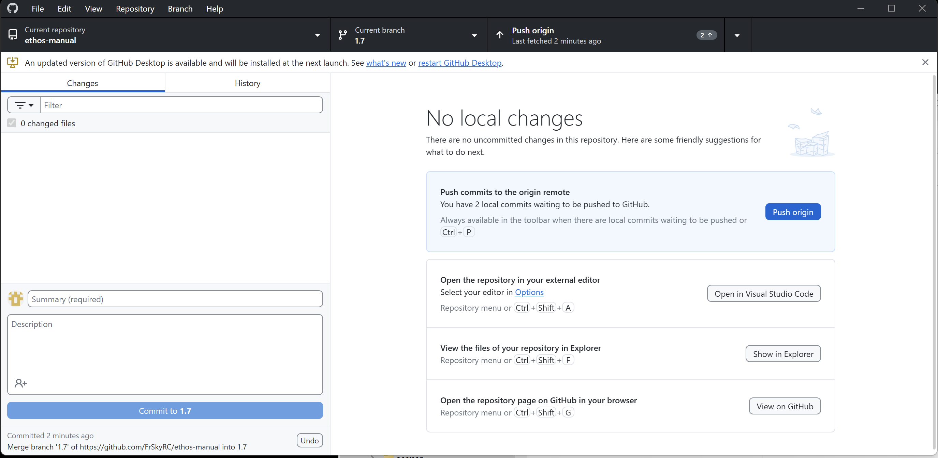

7. GitHub Desktop will process the commit, and then offer the ‘Push Origin’ button. Click on ‘Push Origin’. The status field in the top bar will indicate that the Push is in progress.

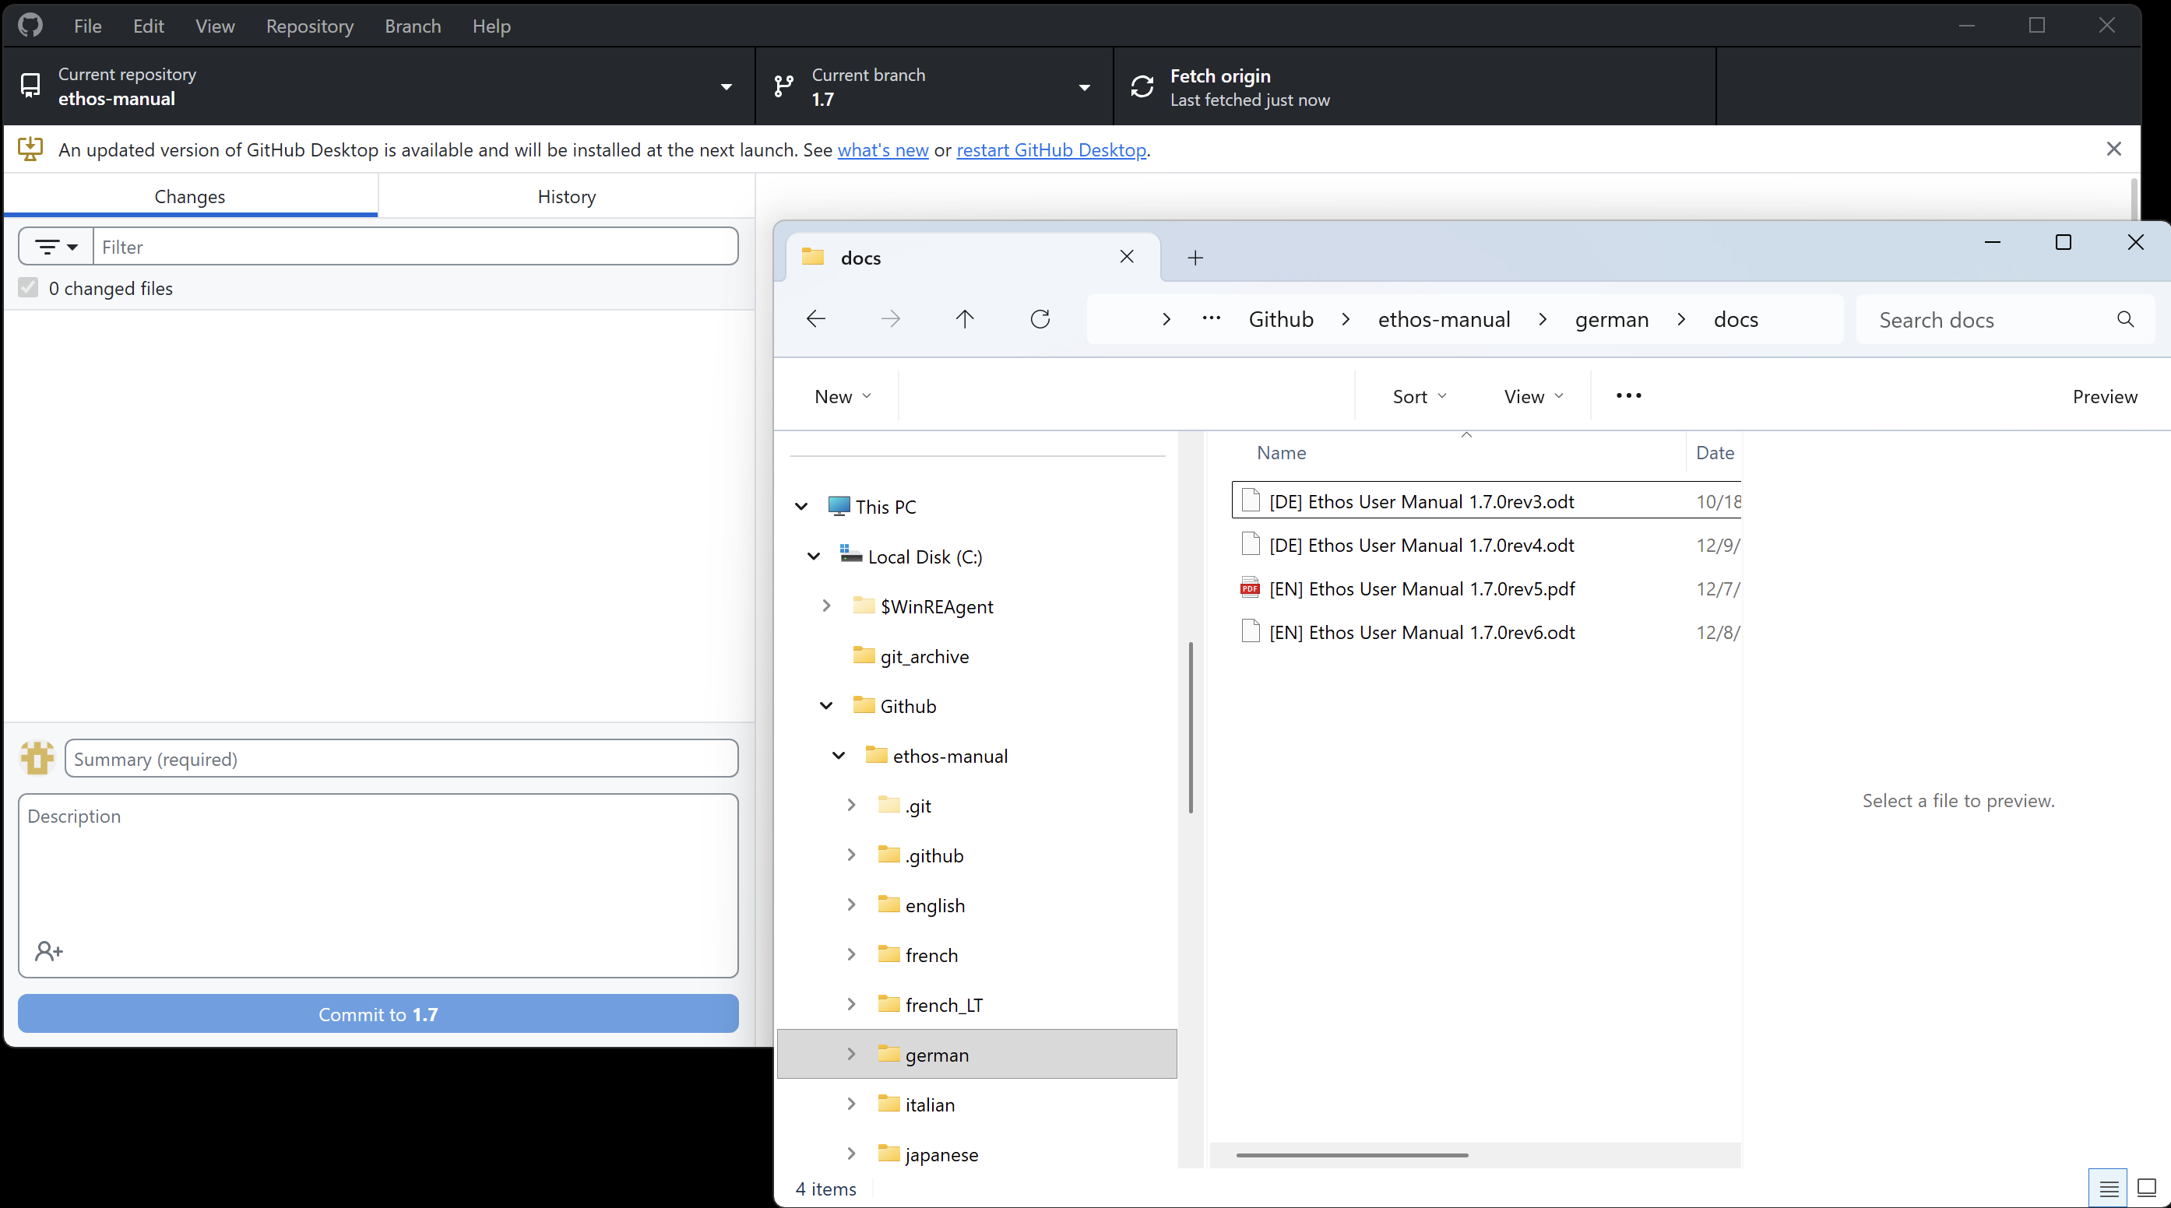

8. The Push will upload your files to the remote GitHub ethos-manual repository. Once completed, it will automatically do a Fetch as shown above. Confirm that it shows ‘0 changed files’ under the Changes tab.

Note: After making the above screenshots, I reverted the commit which had put two EN files in to the DE folder.

Releasing your completed manual
1. First upload the manual files , as described above in ‘Uploading your completed manual’.

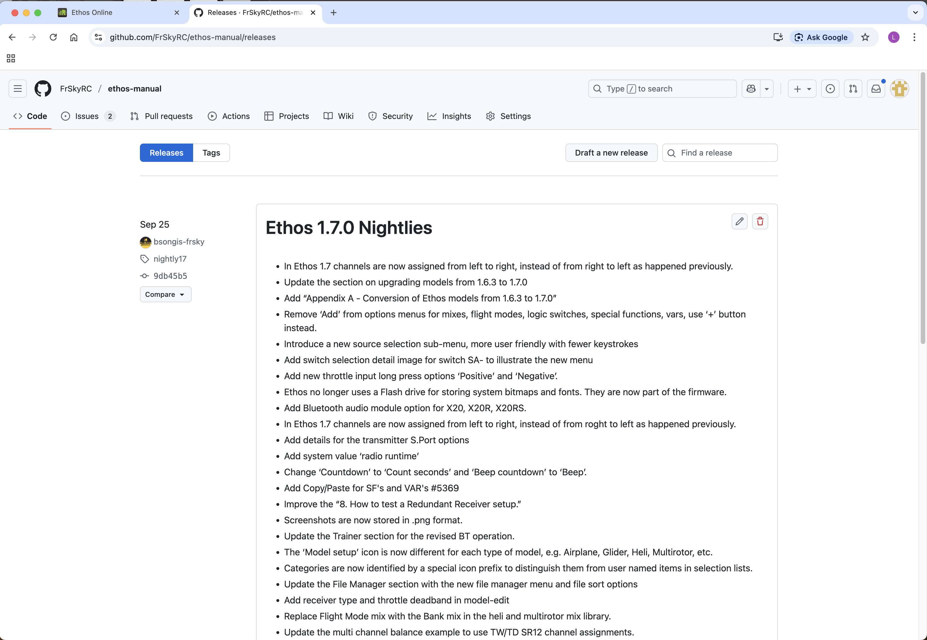

2. Ensure you are logged in to GitHub in your we browser, then click on the Edit button (Pencil icon).

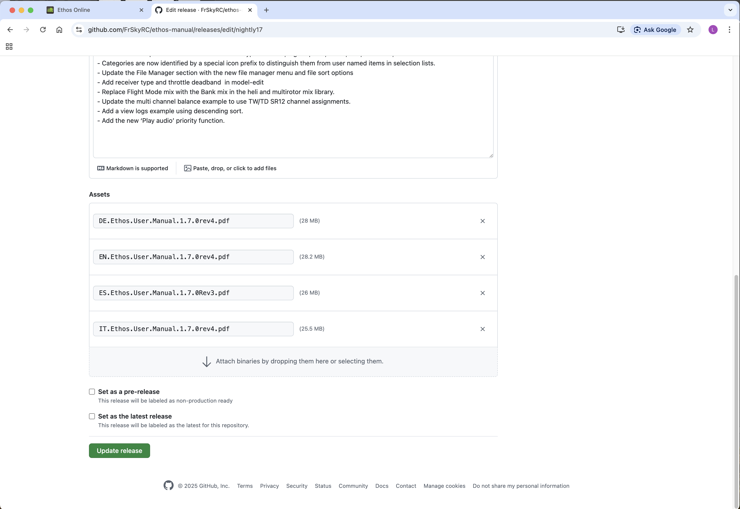

3. Upload the manual PDF file by dragging it to the panel, or by browsing to them.

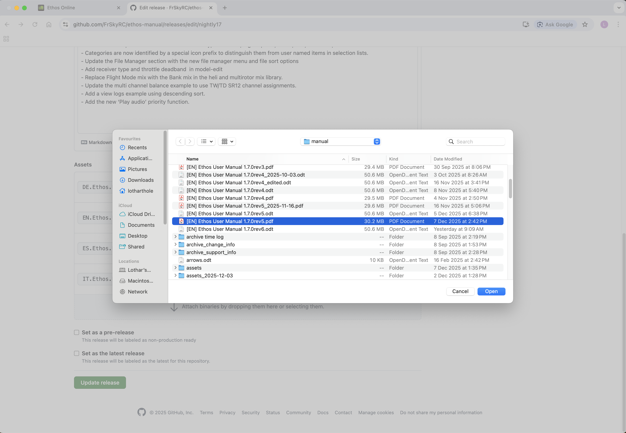

4. Select the manual file and click ‘Open’.

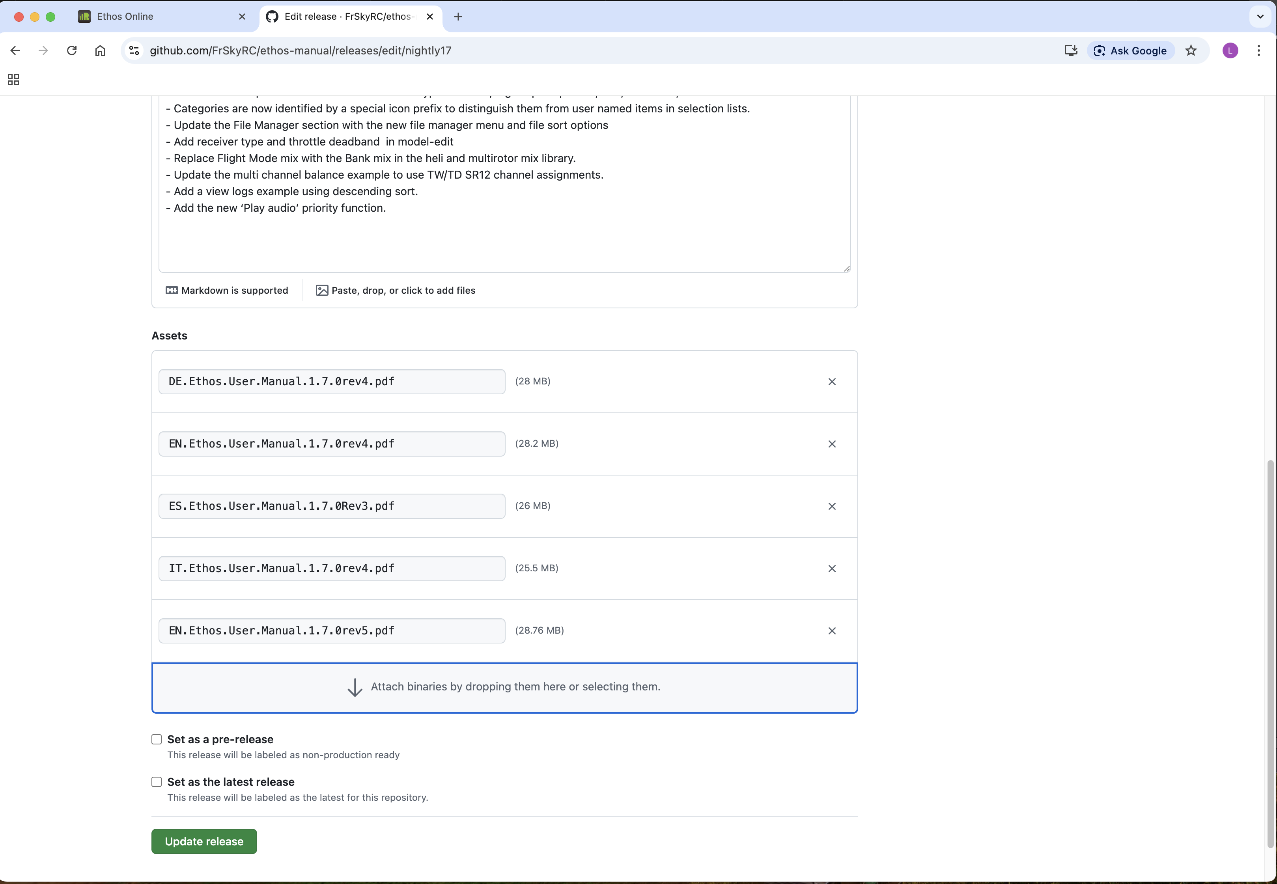

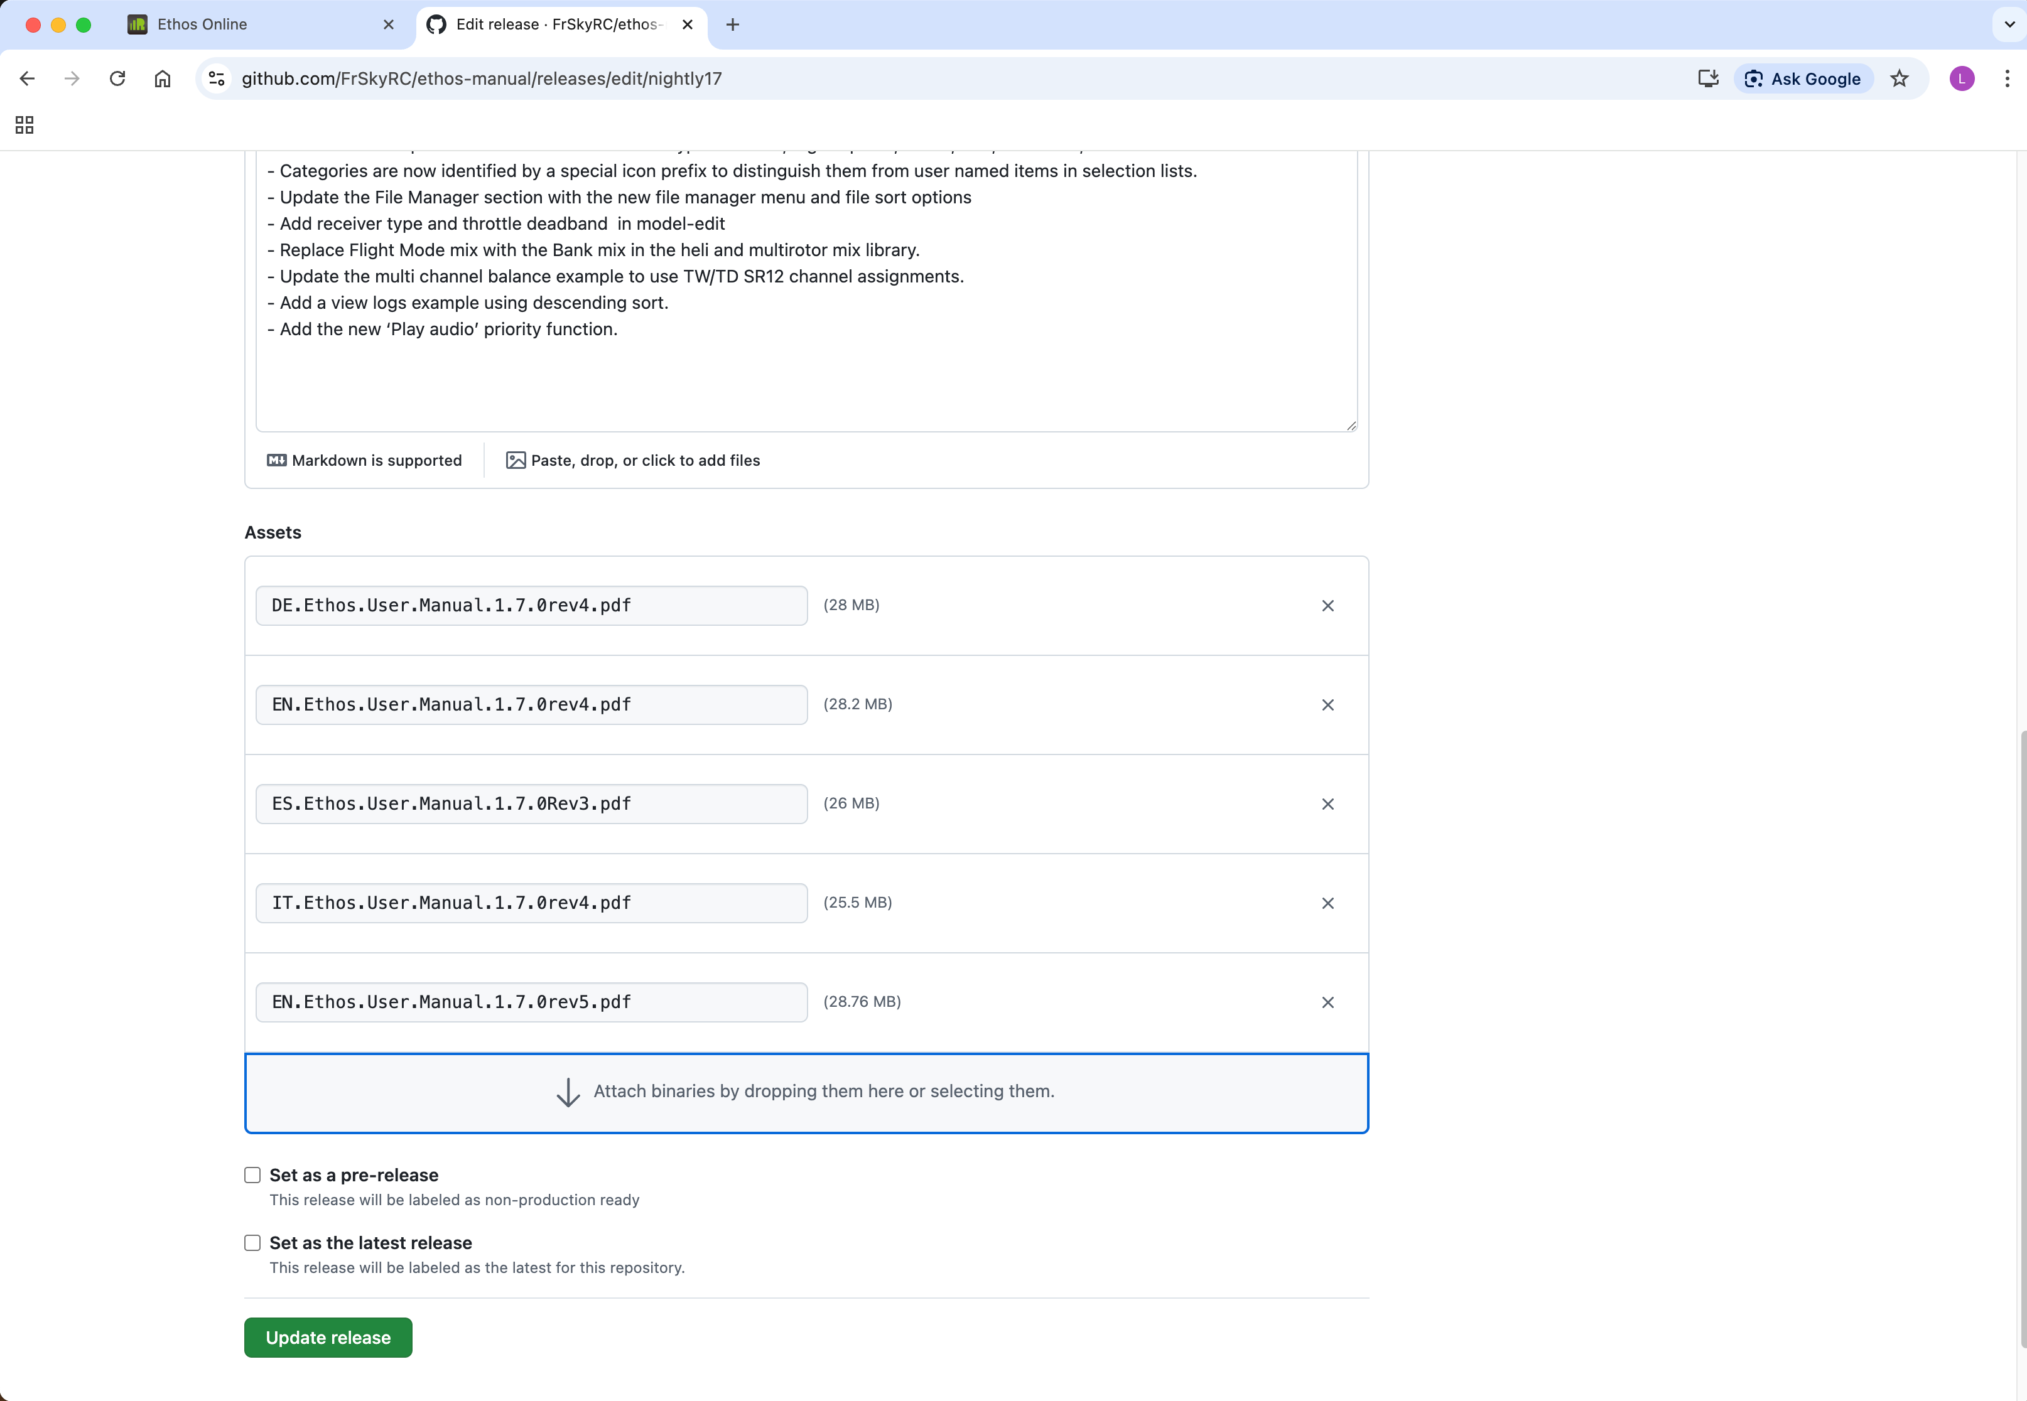
5. The manual has been uploaded.

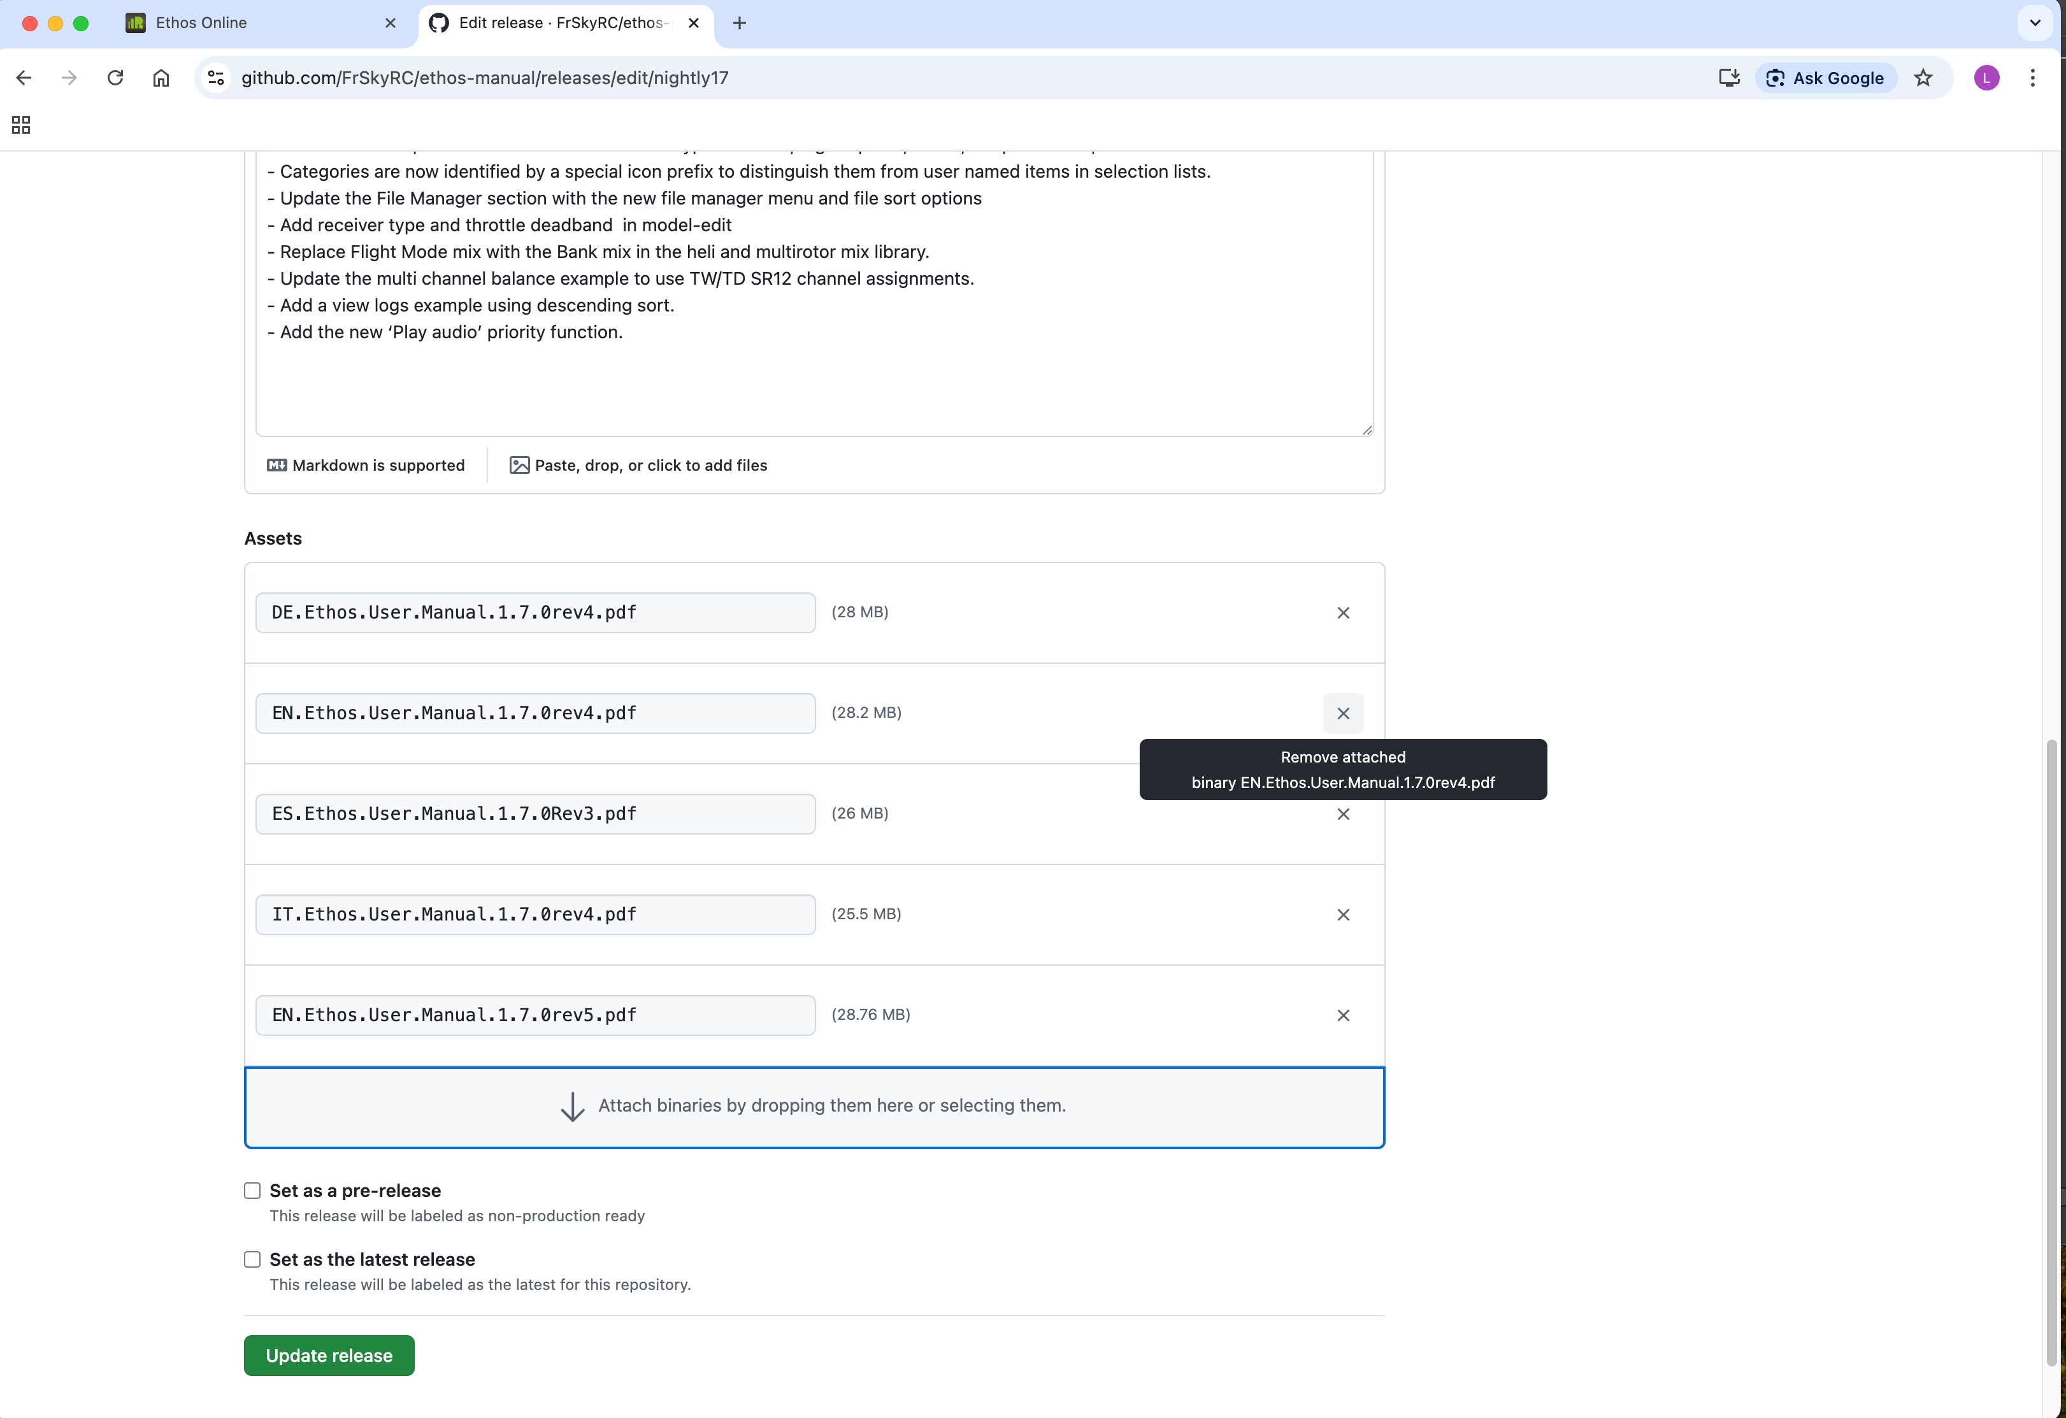

6. Now delete the previous revision by click on the ‘x’ next to it.

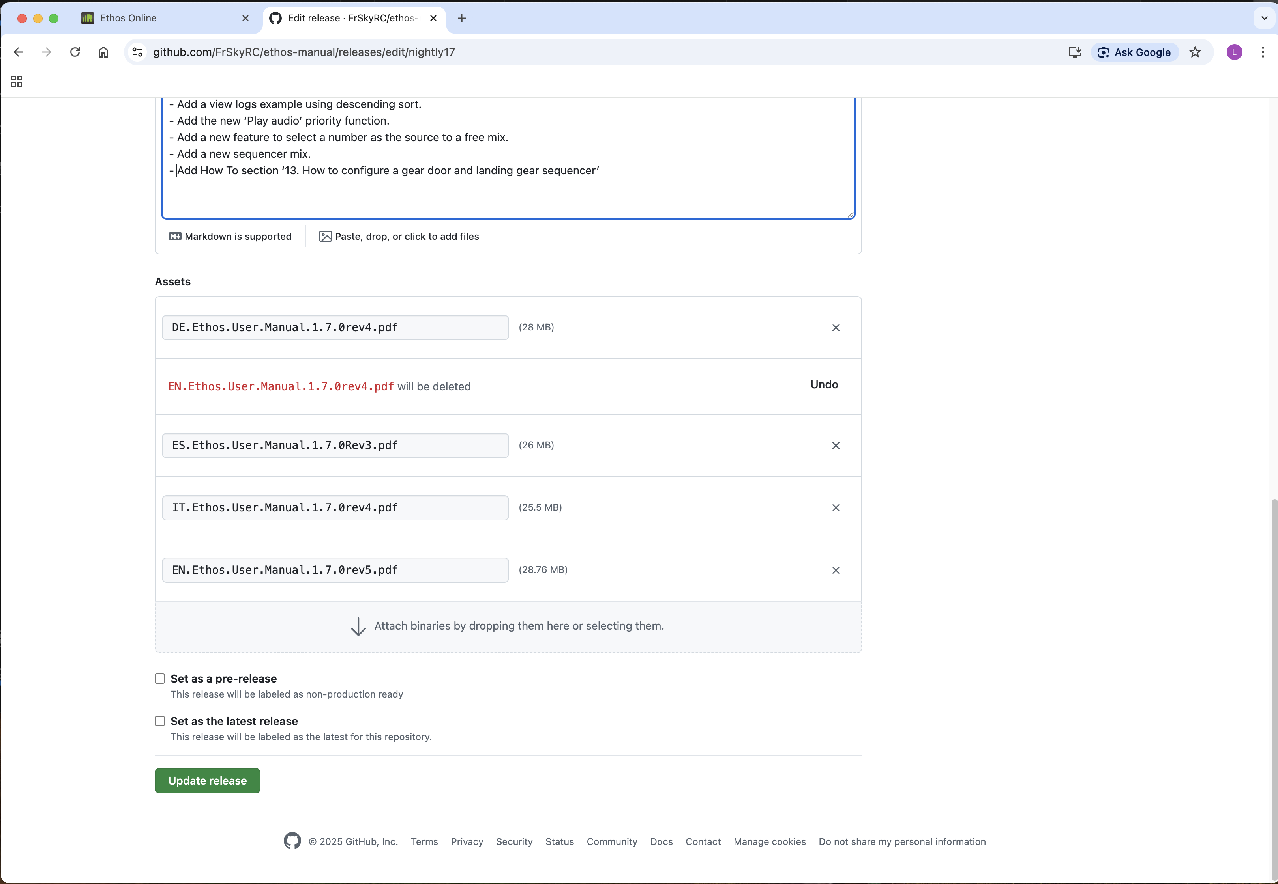

7. Finally click on ‘Update release’.

Dealing with an unexpected merge request
A Merge request most likely means that the remote repo was updated between your last Pull and when you pasted files into your local repo.

If it has just happened, you may be able Revert what is in your Changes tab, followed by a Pull to get your local repo back into Sync.

You may also get an unexpected merge request if you haven’t religiously followed the Pull, Commit, Push sequence. For example, when wanting to upload your file you may have done a Commit and Push without first synchronizing your local repository to the remote. There may have been files already Committed and Pushed by someone else which you needed to get into your local repo before Committing and Pushing your later file. In this case it may be difficult to revert your changes and

7. If all else fails, refer to the next section on getting rid of your local repo and cloning a fresh copy.

Removing your local repo and starting again
The local repository exists so that you can make changes to the repository while offline. It is only a copy of the remote repository online, which is the ‘master’.

It can happen that the local repo gets ‘messed up’, perhaps by something you have done wrong. For example, it may list a large number of changes under the Changes tab which you believe should not be there.

The solution may be to remove the local repo and to clone a fresh copy from the remote repo.

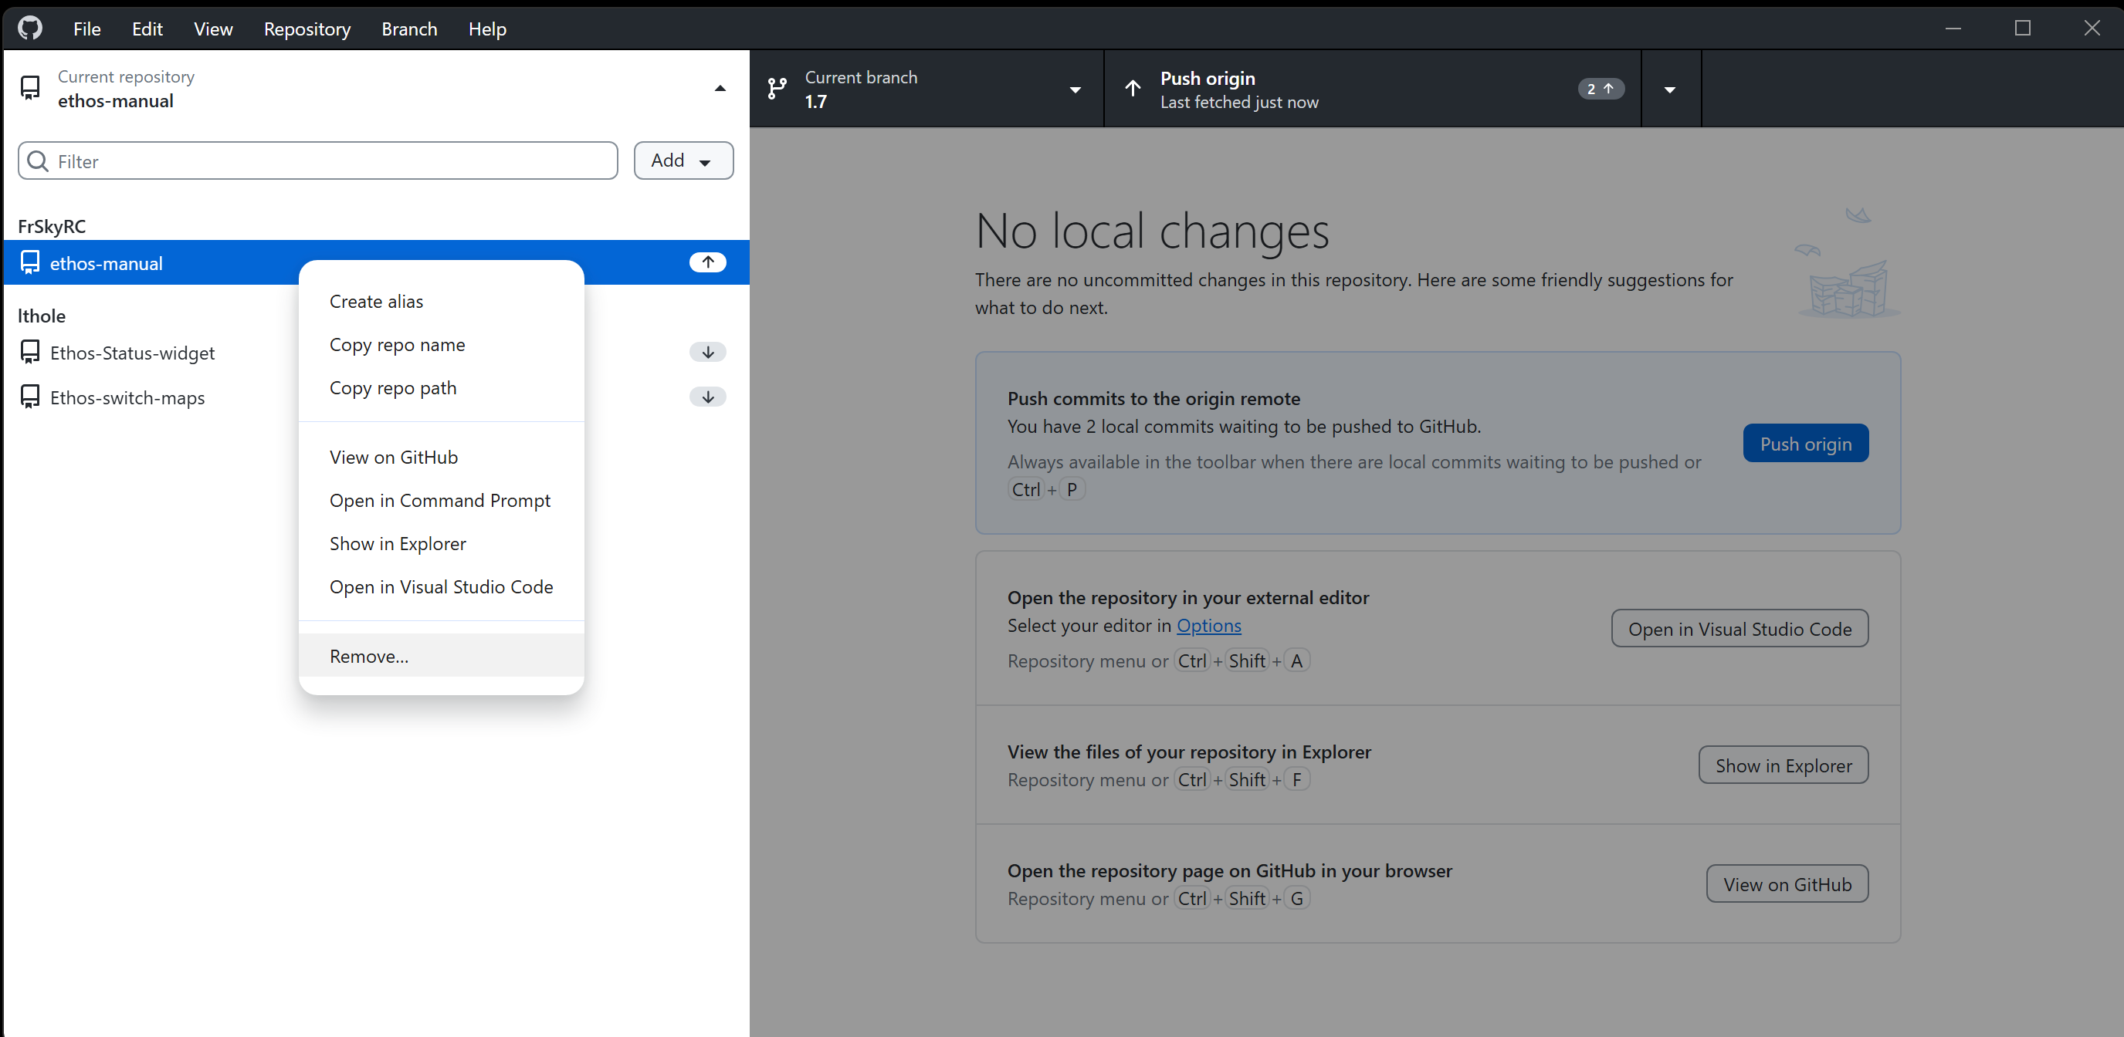

1. Click on the ‘Current repository’ at the top left of the GitHub Desktop window, then right-click on the repo you want to remove.

2. Select ‘Remove’ from the dialog options.

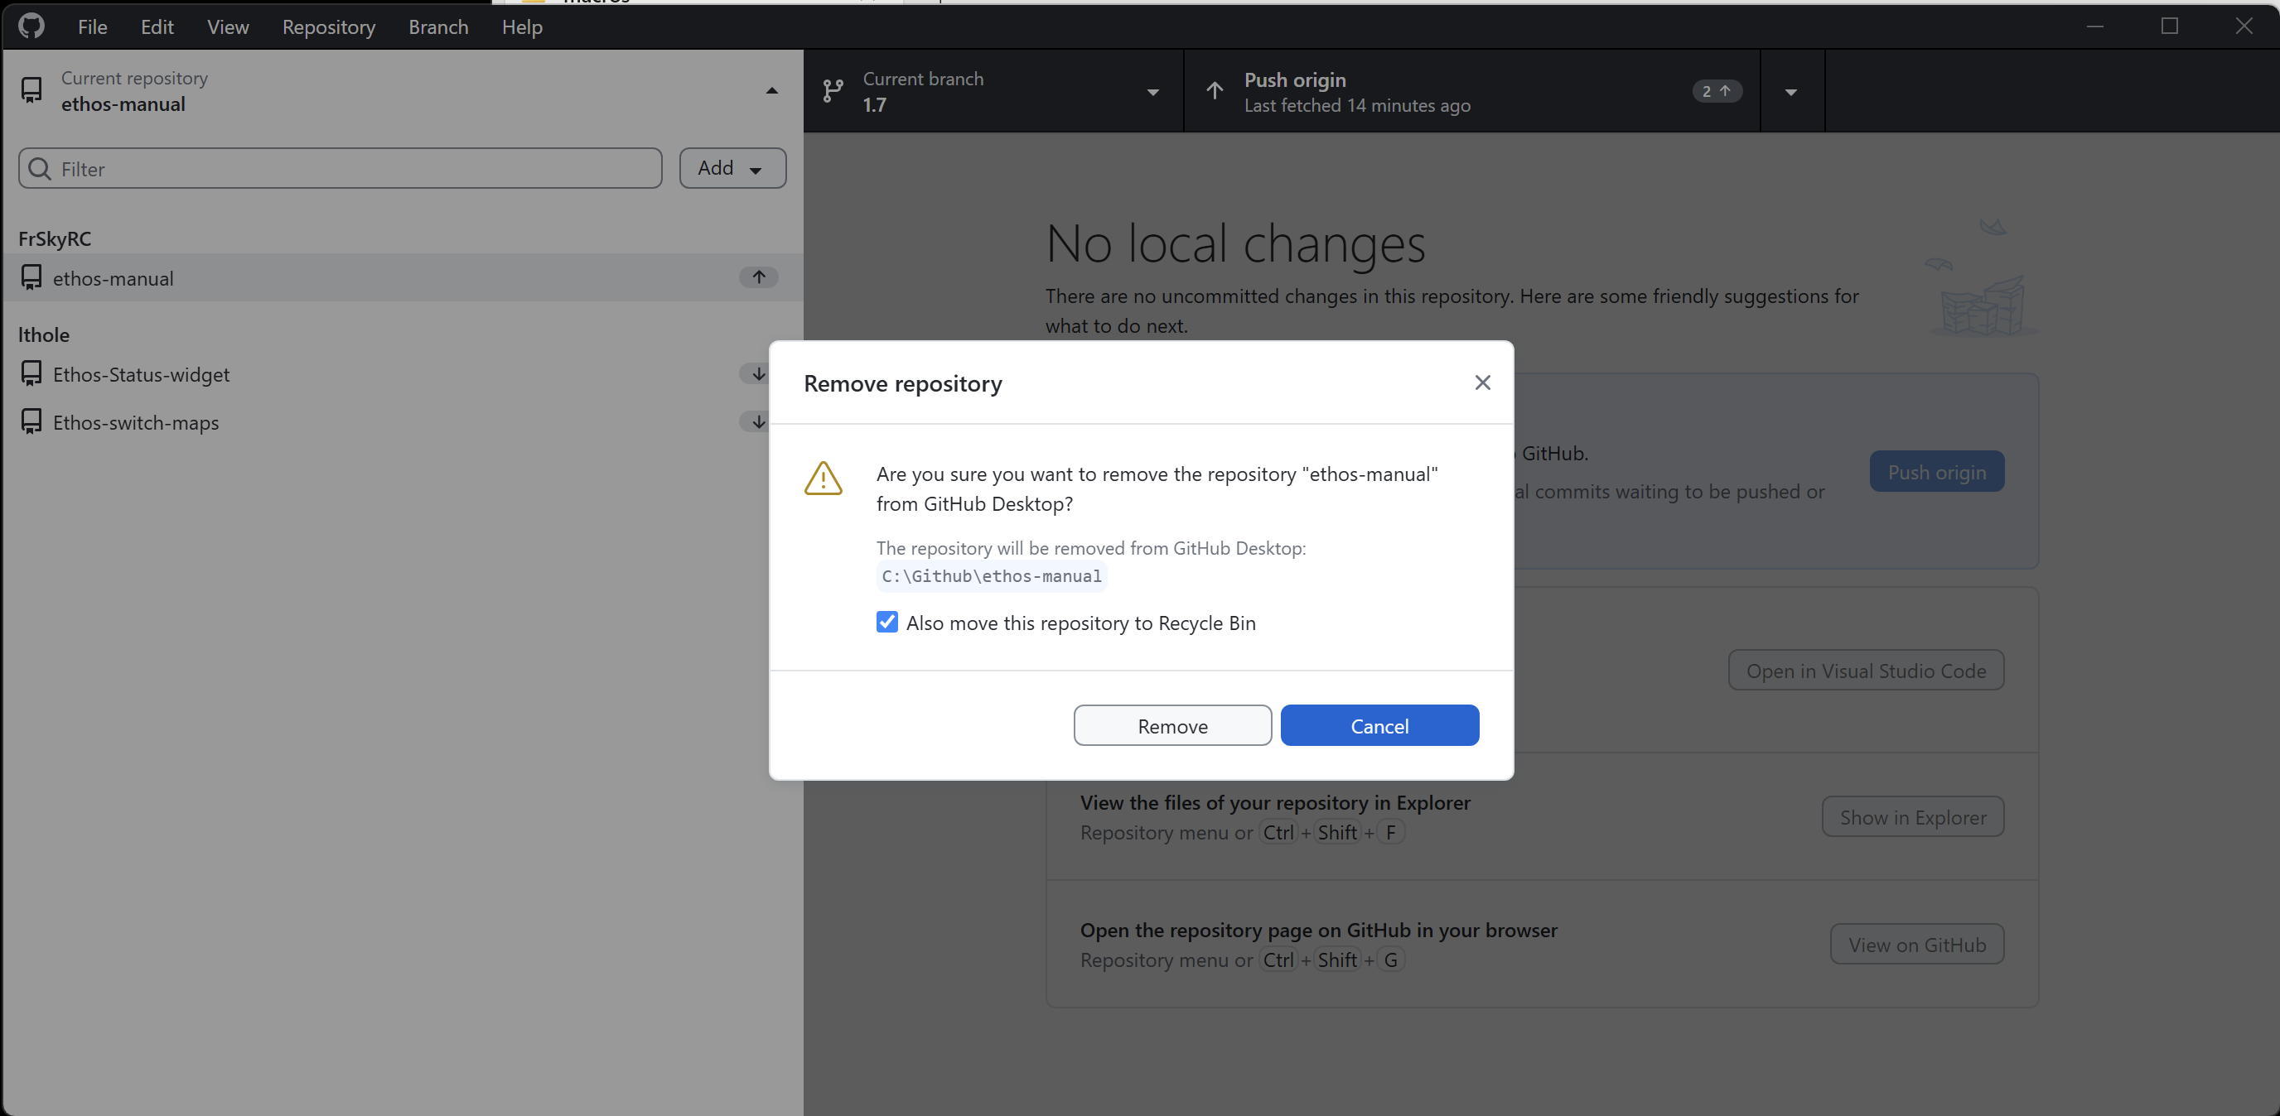

3. You will be asked to confirm that you want to remove the repo. After making doubly sure that you have selected the correct repo, select the option to ‘Also remove this repository to Recycle Bin’, then click on Remove.

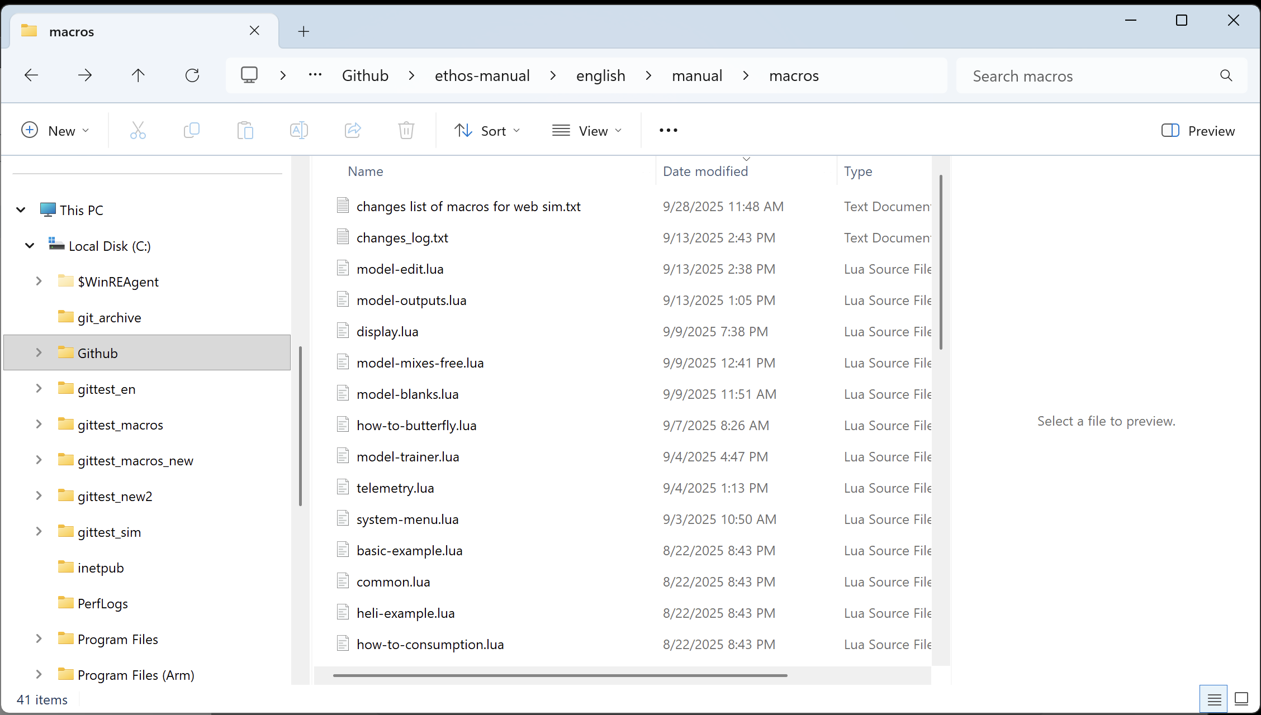

4. Check that the GitHub folder has been removed. (The above example shows where the GitHub folder is in my system. It would disappear after the removal.)

5. Now follow the steps at the start of this manual to ‘How to clone ethos-manual to your local machine’ to make a fresh copy of the repo.

